Talent 2050:
Engineering skills and education for the future

Phase 1 and 2 Research Pack

A review of existing studies and workshops around the UK on current and future engineering skills development

By Paul Jackson (Jasia Education Ltd), Robin Mellors-Bourne (Careers Research Advisory Centre), Nitin Dahad (TechSpark Ltd)

Powered by: The National Centre for Universities and Business
Supported by: Barclays, London South Bank University, NATS and Pearson

Contents

Foreword

Executive Summary

Recommendations and Themes

Background to Talent 2050

Engineering, digital and STEM skills

Scope of Rapid Evidence Assessment

What are the key STEM and digital skills of interest?

Understanding skills supply – trends in UK STEM subject education

Predications about the future economy and skills

Emerging issues and themes

Some existing responses and points of interest

The skills mix of the future – requirements, provision and resources

Appendix 1: Phase 1 Workshops – methodology and reporting

Appendix 2: Sources quoted in the Rapid Evidence Assessment, July 2018-08-22

Appendix 3: Phase 2 Workshops – methodology and reporting

Appendix 4: Phase 2 Workshop briefing pack
Introduction

Much has been done in recent years to stimulate the supply of trained engineers into industry. Engineering UK and others have invested substantially in encouraging a larger and wider group of young people to enter the profession. While such initiatives have seen their successes, these have not been sufficient for us to be able to look forward to the middle of this century confident in the knowledge that there will be the right number of employees armed with the right skills and attributes to enable our engineering industries to thrive.

The number of replacement employees needed alone is a challenge. To this we must add potentially further difficulties in recruiting from oversees. Plus the UK’s poor productivity and the desire of politicians and others to rebalance our economy towards production and away from services. And this is before we address the enormous changes and opportunities in the form of AI and materials and other developments that our engineering industry is likely to encounter in the years ahead. In this context we need to explore, identify and implement ways to increase the provision of well-educated, well-trained and well-motivated entrants into engineering.

The year 2050 seems a long way off. However, it takes 20 years to take a generation from early years to graduation. We therefore have just 10 years to identify what works and what we need to put in place. While this may not seem a “burning platform”, given that we have spent 40 years failing to address these issues successfully, we must act now to develop the evidence, apply the radical thought and take the necessary steps if we are to have a hope of meeting this complex, but potentially highly rewarding, challenge.

Professor David Phoenix
Trustee, National Centre for Universities and Business
Vice Chancellor, London South Bank University
Chair, MillionPlus Association of Modern Universities

Executive Summary

Phase 2 Staying Competitive through Disruptive Change
For Britain to compete globally in the middle of this century it needs high level engineering skills within a diverse workforce, ready to lead through unprecedented disruption and global competition.
This Talent 2050 programme identifies areas of potential disruption, explores changes required to meet today’s, and future, challenges with relevant and effective education, and recommends changes to enable future prosperity.

In the first phase of the work we set a baseline for the skills needs in engineering today and used workshops to explore the barriers to entry into engineering roles, identifying that a broader skillset ready for disruptive change will be required and will only be possible through attracting talent at different career stages and from different sectors, which we termed intersectoral mobility.

In this second phase we used workshops in six locations and an advisory group to tap into the hopes, aspirations and expertise of 150 people, aged from 17 to over 70, and asked them to think about the disruption coming, the skills needed to handle those new challenges and how that learning could be supported, educationally and through funding.

We found broad support for a mixed economy in education with an expectation that the state should fund the foundations and a mix of individual and employer funding throughout a career. The skills identified as essential in the future were again broad, around one third in the more traditional engineering footprint and two thirds in the broader people skills, environmental awareness, adaptability and particularly communications.

This range of future skills reinforced the potential for recruitment of those with great employability skills but limited direct engineering skills and providing the support to move into the engineering sector. It was notable that the teenage participants were incredibly active in online education and ready to learn but saw this as personal development rather than part of their schooling.

Method
The six workshops were held in Sunderland, Rocester, Glasgow, London, Birmingham and Southampton, hosted by Universities, business and a school. In addition to individuals from public and private sectors, education and professional bodies we worked with a group of final year secondary school students to hear from those who will be actively productive in 2050. For this new phase we prompted discussion by sharing in advance case studies of major technology, market and job disruption in photography and recorded music which saw sectors created and companies destroyed, and in logistics.

The baseline Rapid Evidence Assessment (REA) for STEM (including digital) skills focused on current supply and potential future demands using 40 sources when it was undertaken in July and August 2018. Subsequently further published material by Pearson (Commission on Sustainable Learning for Life, Work and a Changing Economy) and Universities UK/CBI (Skills needs in England – the employer perspective') have emphasised the need for lifelong learning through a more effective and flexible system and highlighted a £108bn gain to the economy in getting the right mix.

FINDINGS

Ensuring global competitiveness

Views from the first phase workshops aligned with the themes emerging from the REA, highlighting that known issues are not progressing quickly and meaningfully.

There is slow progress towards the dramatic change that younger participants assumed to be a given.

Broader Skills

Defining STEM and/or digital skills remains a challenge. For employment, necessary core technical skills are needed but also a broader skillset required for practical employability, while a wider ‘digital/STEM literacy’ will be beneficial amongst the public and society. Our workshops identified these broader skills (to make technically skilled people employable) as the most significant missing elements in existing education, predicting a greater need in the future.

STEM initiatives have helped increase the supply pipeline from education, but demographic trends and migration effects outweigh those positive impacts. While very significant barriers and bottlenecks persist, the continuing under-representation of women, ethnic minorities and the disabled in engineering was highlighted by the workshop participants.

Recruitment bottlenecks and barriers

Recruitment and selection processes are not optimised to enhance diversity. In particular fixed qualification requirements, such as A-level physics and Chartered Engineer registration, are seen as a barrier.

The supply of STEM and digital skills via schools is not meeting rising demand. More focus is needed on retraining staff to encourage intersectoral mobility, transferring skills from different parts of the engineering sector and meeting the challenge of recruiting talent from outside engineering.

Intersectoral mobility

Intersectoral mobility and recruitment will be more important if the UK is perceived to be a less welcoming work or study destination post-Brexit.

Workforce planning is not practised widely in the UK and a lack of centralised thinking may impact our ability to define which skills will be required. However, the expected extent of disruption may be greater than catered for in conventional planning approaches.

Employability and technical skills

The message is clear - a range of contemporary (‘21st Century’) employability skills are necessary, along with technical STEM knowledge and skills. More people with technical qualifications, but unemployable due to a lack of soft skills will not drive the sector forward, nor enable organisations to benefit from technological advances in a globalised economy. ‘Digital literacy’ (and to a lesser extent environmental literacy) is gaining momentum to complement core technical and digital skills of STEM professionals.

Educational frameworks, and their accreditation, should include these employability skills. There is potential in a number of initiatives to overcome pipeline problems, but more retraining for the existing workforce is needed. Different routes into engineering might provide these skills more effectively. And, apprenticeships might only be relevant to one particular role and/or employer rather than more transferable 21st Century skills.

Major change needed

For engineering to be ever more important to the economy, major changes are needed including a wider range of people with the appropriate skills. The ‘school to apprenticeship or university’ route for young people, even if changed to more effectively develop the skills outlined here, will not address the necessary change quickly enough. In addition to changing attitudes and subject choices of young people we need to consider the attraction of those already in work and how reskilling can be achieved.

Future skills for disruptive change

The work on missing elements in education from the first phase had already guided us to suggest that there is significant potential to recruit from alternative sectors and provide the appropriate engineering knowledge through a mix of training and/or access to the knowledge base. The current model in engineering assumes a pipeline of individuals building a large resource of engineering knowledge, whether through a university or apprenticeship route, which can then be augmented by people skills, management, communication and business, to provide that broader skillset in a career. It is a T shape where the technical knowledge has to be there before the other elements, the horizontal part of the T, can be added. Hence the “leaky” pipeline of talent with no potential to top up later. Key qualifications in that pipeline are massively skewed towards male participation, including A Level physics with a 4:1 male-female ratio and computer science with a 9:1 ratio.
The work in the first phase suggested that there is already potential for intersectoral recruitment where the skills that make the horizontal part of the T are already in place through education or work experience and the missing engineering elements can be added later, opening up the potential to recruit a far more diverse workforce and to enhance that diversity faster than waiting for changes in school-age education to feed through.
The skills suggested by our participants in the workshops match those already identified in the Rapid Evidence Assessment although they do go further, suggesting that three pillars of skills, (people skills, creative thinking, entrepreneurship) alongside a pillar of core technical knowledge and underpinned by ethics could be more relevant to the future with the potential to add layers of technical knowledge in the future as technology changes and the use of artificial intelligence creates opportunities to exploit the existing knowledge base.
Digital skills are seen as a central pillar in all education, not just STEM, and in future jobs. Similarly, ethics and environmental awareness are assumed to be prerequisites.
The Gig Economy
It was apparent from the discussions that these wider skills would support interdisciplinary working and a shift to the Gig economy, which has already been seen in IT, where teams from different organisations or no organisation at all tackle challenges.
We explored the questions related to who should provide the future education and who should pay with each group. Our attendees, almost universally, saw a joint effort to educate, up skill and reskill the population and saw it as an essential part of remaining economically active as individuals and globally competitive for the UK. There was an expectation that the state, individuals and employers should all contribute but also a realisation that the Gig economy could reduce the reach of employers in a traditional sense.
There was a clear view that the process needed to be more collaborative and continuous rather than the current separation between the State and Employers with the principal links between the two being tax, including the apprenticeship levy. There was an acceptance that individuals could be expected to fund their advancement so long as mechanisms were there to support them, both through easily accessible online learning and through access to finance, including loans, for larger investments. The apprenticeship levy was viewed as a missed opportunity and a system with pooled funding, whether through trade associations, regional or national government, should be available to support education and skills training more widely than just large employers.
Attendees fully expected universities, colleges and employers to be part of the training provision, and professional bodies too. The potential to add layers of technical skill, both as part of upskilling and to provide knowledge and skills to a more diverse workforce could be and should be provided by all of these groups.
Online learning
Finally, a significant point for online learning came from our year 13 teenage students at the JCB Academy. They rejected online learning in school. The school system in the UK, particularly in England, has become more focused on imparting and testing knowledge in a disciplined school environment. But, these students were all experts in online learning outside school: every one of the students had used YouTube or other online products to learn make-up tips, use or fix equipment or to support learning in their lives. They did not see the relevance of the online tools to their academic learning. If the UK is to thrive in a technology-dominated future with real global competitiveness, online tools will need to be embraced in education far more effectively than simply putting lectures online. The new generation of adults is ready to embrace this.

RECOMMENDATIONS AND THEMES

Observations for change today

1. The Institute for Apprenticeships and Government should reconsider the requirement for employers to take apprentices to Level 2 in English and Maths by the end point assessment, whilst still encouraging greater literacy and numeracy skills, so employers can be actively encouraged to develop young people who display practical talents.

Barriers and Bottlenecks
1. To drive a more diverse workforce and avoid skills shortages engineering needs to reach beyond existing STEM employees, changing the perception of recruitment from the “leaky pipeline” to a reservoir of talent which is ready to learn.

2. Consider a more inclusive approach where recruitment or enrolment (including professional registration) is based on the potential to gain the right skills rather than because they haven’t already obtained them.

Attracting and supporting intersectoral mobility
4. Ensure upskilling and reskilling are fully supported for those already in work, whether within the sector or bringing complementary skills through intersectoral job mobility. This will need to be regionally tailored and applicable to SMEs, including those in the Gig Economy as well as major corporations.

Changes to Education
5. Digital skills, including AI, and environmental protection provide the foundation for future change and need to be fully integrated, with regional support, in an industrial strategy that embraces interdisciplinary working. They also need to be at the heart of future education more widely.

6. The school system will need to embrace technology for learning, including smart phones, to prepare the next generation to access, filter and apply knowledge that is available online.

7. The education and skills system needs more collaboration between the public sector (national and regional), educators and employers to share resources, set priorities together and support employees, the self-employed and those without employment in a sector or at all.

Background to Talent 2050
There has been much discussion of the need to improve the availability of the skills that impact productivity and a good deal of change with that in mind including the introduction of the apprenticeship levy, new apprenticeship standards and T-Levels. Where this study aims to add value is in taking a look beyond today’s productivity horizon and attempting to inform the thinking on the needs of our education and skills system in the middle of the century. It is intended to be the first of a series of projects to shape future education and skills provision, setting the vision first and then building the structures to deliver with subsequent projects that could look at the international scene, the structures for learning and accreditation and other aspects.

Although the study is restricted to engineering skills, this is not intended to be limited to the current engineering sector and encompasses the growth in digital skills and artificial intelligence which will impact large swathes of the economy and the merging of disciplines to find solutions.

This study builds on the existing work of the National Centre for Universities and Business, specifically the Talent 2030 Programme which has been addressing diversity.

Of these five themes, three will be addressed directly in this study: ideas, people and places. Infrastructure and the business environment will be considered, particularly in the context of how education and training can be accessed and funded. The forward look will recognise the NCUB’s purpose in “Promoting business-university collaboration for a prosperous and inclusive economy” without being limited by today’s scope of that collaboration.

This report includes four key elements:
- The results from workshops around the UK on current provision and future needs for engineering skills.
- A rapid evidence assessment to baseline the current state of play in engineering education and skills provision.
- The results from the second phase of workshops that covered future skills needs and how to provide them.
- A set of recommendations related to the barriers that impact the availability of skills in quantity, quality and variety for future needs.

We are grateful to London South Bank University and Jasia Education Ltd for supporting the first phase of the project and to CRAC for undertaking the Rapid Evidence Assessment. The second phase has been supported by Barclays Bank, Pearson and NATS and the workshops have been hosted very effectively by the JCB Academy and the following Universities: Sunderland; London South Bank; Solent; Glasgow Caledonian.

Engineering, digital and STEM skills

Scope of the Rapid Evidence Assessment
This Rapid Evidence Assessment (REA), conducted in early July 2018, was undertaken based on a series of parameters to constrain its potential scope. It was agreed to focus on STEM and digital skills/subjects/occupations reasonably broadly. Practically, the key inclusion criteria were known research and policy-related reports and review articles/papers published within the past 5 or so years (with some exceptions), excluding blogs and press articles. No searches of the academic published literature were made, so the REA was deliberately purposive at least in the first instance, although some additional articles cited in those first-level sources were subsequently included. Although the primary focus was on the UK, based on UK sources, some international perspectives were included. For the first pass, 40 sources were included and reviewed.
- What are the key STEM and digital skills of interest?
Some useful definitions are reviewed by the RAEng, quoting an old Accreditation Board for Engineering and Technology definition of engineering itself: “The profession in which a knowledge of the mathematical and natural sciences gained by study, experience, and practice is applied with judgement to develop ways to utilize, economically, the materials and forces of nature for the benefit of mankind.” This suggests that engineering skills are essentially knowledge of the underlying mathematics and natural sciences and the principles of how to apply them (STEM subject knowledge) together with more practical skills of how to implement such applications (including some ‘softer’ skills like project management and collaboration). Meanwhile technology is seen more simply as an enabling package of knowledge, devices, systems and processes created for a specific purpose. Increasingly, this is of course digital technology.
However, technological advance means that digital skills are a moving target for definition. The Readie centre hosted by Nesta suggests that there is no single set of competencies appropriate for all settings and individuals, but that any framework or definition for digital skills needs to identify the people needing them, the context/place in which they need them and the timeframe. As technological advances create needs for new technical skills, their deployment changes the environment in which people live and work. Van Laar et al argue that to satisfy the demands of the 21st century workforce, which operates in a digitally underpinned society and economy, an expanded conceptual framework is needed that includes both technical digital skills and ‘21st century digital skills.’ These are the skills needed to participate in a knowledge-based workforce and society (i.e. to take full advantage of ICT). Van Laar et al. envisage the most common seven core skills to be technical ability, information management, communication, collaboration, creativity, critical thinking and problem-solving, to which they added a range of ‘contextual’ skills including ethical awareness, cultural awareness, flexibility, self-direction and lifelong learning.
Arguably, a somewhat similar development of understanding (to that of the different types of digital skills, or skills for a digital economy) has been the emergence of thinking around “green skills.” There seems to be a growing consensus that in order to tackle climate change and environmental challenges, there needs to be an increase in the availability of “dark green” skills – the technical skills at the heart of low-carbon technology and its development and deployment – but also in the extent of “lighter” green skills and “environmental literacy” in wider society. These lighter green skills include a knowledge set for all sectors/workers to advance the adaptation of workplaces and working practices to tackle climate change, as well as a more generalised literacy amongst wider society so that people are more informed consumers and users.
2. Understanding skills supply - trends in UK STEM subject education
Trends in study of subject disciplines during education are arguably the most consistently monitored aspect when considering skills, due to the public sector’s role in the provision. Engineering UK, in turn, consistently reports trends on an annual basis at school level and in post-compulsory education, in its annual statistical digest. Many of these are also usefully highlighted in the recent National Audit Office review. Trends at GCSE level are confusing due to the variety of qualifications which include combined science options as well as single subjects, against a backdrop of a demographic dip in the number of teenagers in the UK. What is more important is post-compulsory study of science and maths, post-16. STEM A-level examination entries have risen over the last 5 years, despite a total fall in entrant numbers (due to the demographics and some competition from BTECs). STEM subjects accounted for 35% of all A level entries in 2016/17 (up from 32% in 2011/12). But this overall growth masks concerns in some subjects. Physics and chemistry both grew in 2016/17 after recent declines, while biology is now falling slightly after rises. Maths continues to rise steadily, and further maths more rapidly although from a much lower base. Computing doubled in the last year although also from a low base, while D&T fell sharply. There is a consistent gender participation gap in most STEM subjects, with females comprising 42% of all STEM A level entrants but just 9% in Computing and 21% in physics (but 62% in biology).
The recent Roehampton report charts the increasing number of schools that offer computer science at GCSE (>50%) and at A level (>35%), and growth in student numbers (now 12% of all students at GCSE and <3% at A level). Most GCSE computer science students are academically strong, mathematically able, taking triple science, and overwhelming likely to be male (90%) and middle class. Computer science is quite different from ICT as a qualification and taken by different students. The decision to remove ICT as a qualification at GCSE and A level seems likely therefore to result in fewer, and rather less diverse, students overall taking a qualification in computing. The report suggests there may be a need for a more direct replacement for the ICT qualification at GCSE and A-level, which would encompass all three of the computing, IT and digital literacy elements that were recommended by The Royal Society in 2012, which would presumably sit alongside the more specialist computer science qualification which currently appeals only to a narrow niche (which would possibly make the situation akin to that of maths and further maths A levels, respectively).
Including specifically for computer science, the shortage of STEM teachers is becoming critical, however. Despite Department for Education protestations around the high numbers of teachers in total, the reality is that both recruitment and retention of STEM subject teachers, especially for maths, computing and physics, is of serious and deep concern, alongside the under-funding of maintained school provision. This is particularly ironic at a time when numbers of entrants to maths, especially, are steadily rising.
There seems little value in looking at vocational/technical/further education trends until T levels are established. However, the total number of starts in STEM apprenticeships grew 18% between 2012/13 and 2016/17, driven by growth in engineering and manufacturing technologies and construction, planning and the built environment, although this preceded the most recent sharp falls recorded in starts following introduction of the Levy. For brevity, it seems likely that numbers will stabilise, and continue to rise at the highest levels as degree apprenticeships begin to take off. However, females made up only around 8% of STEM apprentices in 2016/17, despite representing over 50% of all apprenticeship starts, and the proportion of BAME students is also very low, so the apprenticeship pathway is doing little to diversify the skills pipeline, and possibly the reverse. Young women and young people of BAME origin continue to represent a pool of potential STEM‑skilled people currently being lost to the economy.
In higher education, trends in participation by UK students are also well documented. Overall, there has continued to be some growth in full-time HE study although in many recent years this has been more than offset by the fall in those undertaking study part-time (which may now be stabilising). Numbers in engineering and technology subjects have risen over a 10-year period but tailed off recently; that growth has been driven largely by international students, so the trend in UK-domiciled student numbers has been far less healthy. Postgraduate level study in engineering and computing is dominated by international students. At Masters level, many courses would not be sustainable without international student participation; if eligibility to study decreases or the UK is seen as an undesirable study location, the ability to train UK graduates at MSc level in engineering or digital skills could be lost as these courses may become unsustainable. Some of the international students become the researchers and teachers in these subjects when they remain in the UK, a critical pipeline for future skills development. The new Masters loans introduced in 2016/17 have resulted in an upward tick in the total extent of study, including in engineering, and also seem to be widening the ethnic mix of those pursuing higher levels of study, but it remains to be seen whether this increase will be sustained.
What is relatively clear is that the UK has spent a great deal of time, effort and money on initiatives to encourage more young people to pursue STEM qualifications post-16 upwards, and more recently to highlight the potential value of the STEM careers that these qualifications open up. The National Audit Office has concluded that some of the £1 billion spent by the UK on these STEM initiatives in the last 10 years has had positive effect, in terms of the numbers studying STEM subjects post-16 and in HE. However, it believes there is a real lack of coordination across these initiatives which has hindered the overall impact of this investment. A key study which has been largely overlooked by STEM providers has been a longitudinal national evaluation of STEM ‘enrichment and enhancement activities’ conducted using school and pupil level data from the National Pupil Database. This looked at three main educational outcomes to assess the impact of STEM enrichment and enhancement activities: (a) school performance in terms of percentage of pupils achieving a ‘good’ GCSE grade in science and maths; (b) GCSE attainment in science and maths of the pupils; and (c) continued post-16 STEM participation. Analysis of the school-level data did not show a direct impact of these activities on improved school GCSE performances. Based on the entire 2007 cohort across all maintained secondary schools in England, it was concluded that GCSE attainment of pupils in science and maths was not affected by participation in these activities. Pupil background characteristics were far more significant and outweighed whether the pupils had actively registered in these activities. Finally, there was no direct noticeable impact of these activities for 11-16 year olds in school on STEM subject take-up post-16. Banerjee’s somewhat generous conclusion, given the huge resources involved in the delivery of these initiatives, was that there is a need to identify what works, and if any of these schemes work better than others.
We asked our workshops to look at the attractions of a career in engineering to give an understanding of the factors that those in the sector have found attractive and would expect to attract others.

2.1 Attraction of engineering careers

Knowing that most participants were in, or closely tied to, the engineering sector today, the results were not particularly surprising in the ice-breaker sessions on attraction into engineering.

The dominant themes in the attraction discussion were Family, Career, Practical, Problem Solving and Exciting. It is difficult to translate these themes into recommendations for action but they do serve to emphasise that awareness of the potential to develop and be rewarded for engineering skills in the past has come through family and friends. It is important to go beyond this group to reach additional numbers and a more diverse talent pool.

Caution needs to be extended around the word Diverse. This was used in the sense of variety, both in applications and in multidisciplinary projects, rather than diversity and inclusion (which was significant in the section on barriers).

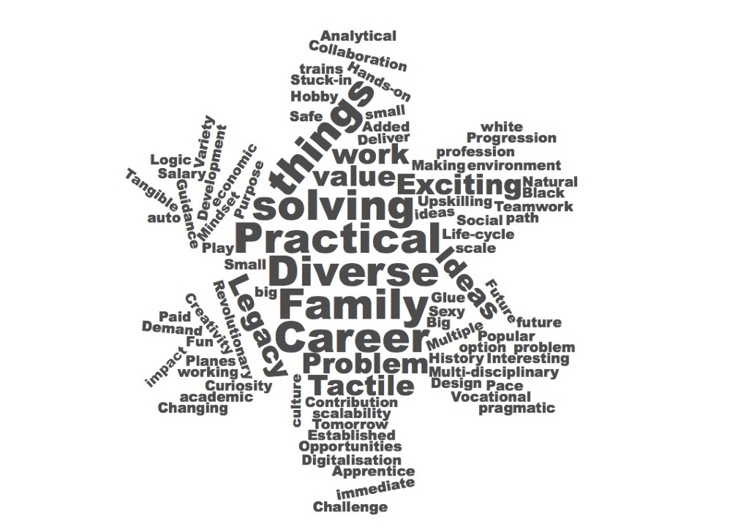

Salary was raised as an attraction in the North East and a barrier in London and Edinburgh.
It is hard to imagine what more effort could be put into encouraging higher numbers of students to study of STEM subjects post-16, short of compulsion, and the lack of any shift in the proportion of girls taking physics A-level is particularly telling, despite decades of effort of differing kinds. This seems to suggest that there are very significant barriers at play, which remain stubborn in the face of the well-intended policy initiatives to date and could continue to impact on the extent of STEM-qualified young people available to enter the workforce, i.e. the potential supply. Of course, whether they choose to do so, and provide their STEM skills within occupations and roles that we ‘count’ in terms of STEM skills demand is another matter. It also begs the question of whether a greater effort should be made to re-train those already in the workforce in STEM skills, rather than relying on the pipeline of young people entering the labour market from education.
In this context, our second workshop session on the barriers to engineering careers may provide some useful insight into why these efforts have not been as transformative as the sector had hoped and certainly not witnessed the change in other professions including the gender mix in medicine.
2.2 Barriers and bottlenecks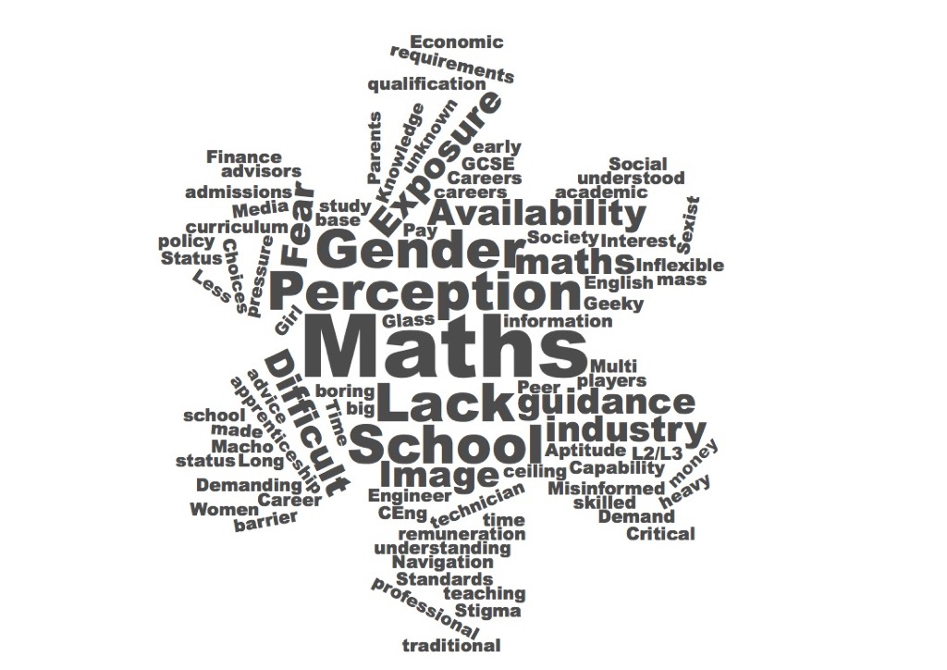

Discussions on the barriers to developing engineering skills through work-based or college/university learning proved to be varied but broadly broke down into two categories: societal attitudes and academic requirements. Given that the participants had, in most cases, chosen to go into engineering, the participants were asked to think about friends, colleagues and students who had not. What had put them off or prevented them from following a path to an engineering course or job.

In the word-cloud presentation the dominant word is Maths, in the latter category while perception, gender and guidance are notable societal themes.

The focus here is to identify changes that the sector can make or press for through realistic policy initiatives rather than to suggest that it is well placed to change broader society. The two themes are not wholly independent. A requirement for maths and physics qualifications, for example, to progress into work or further study will immediately shape and limit the pool of applicants whether they are interested in the roles or not, as identified in the Rapid Evidence Assessment. It is interesting to note that Chartered Engineer registration was identified as a barrier and further discussion revealed that this was in the context of requirements that were perceived to exclude many and to be too complex. This may be in the application of the requirements rather the registration standards but the perception was certainly that the rules were too rigid.

The group in the North East identified specific barriers to apprenticeships. There was concern that a few large companies had dominated the crafting of the apprenticeship standards, probably because smaller companies had struggled to find resources for a meaningful engagement, and this limited the appeal in the wider supply chain.

There was also significant concern regarding the requirement for apprentices to achieve Level 2 qualifications in Maths and English by the end point assessment if they had not already attained GCSEs at C or 4 grades when at school. This was viewed as a massive disincentive for employers to take on young people who had not achieved GCSEs in one or even both of these subjects during the dedicated teaching and learning in schools.

With current statistics suggesting that three quarters of young people retaking these qualifications will not achieve them by the age of 19 the employers’ concerns are understandable. If employers are unwilling to take on this task, which was the indication here, they would exclude at least 40% of the pool of young people in the North East.

From an applicant’s perspective, the complicated systems for application and progression were viewed as a disincentive and potentially a real barrier, particularly in the context that careers advice and guidance is weak in schools and largely absent beyond formal education.

A barrier was also identified in relation to gender, both in the headline term and in terms like “macho” and “sexist”. In the discussion, there was no suggestion that the sector was institutionally sexist but a combination of the historic lack of women in engineering and the recruitment from a male-dominated pool with the desired qualifications already in place could be seen to have that effect. The barriers that stand in the way of other groups that are currently under-represented in the engineering sector, compared with the general population, were not highlighted although similar constraints would apply to strict qualification requirements where we have data including black and minority ethnic groups.

The Rapid Evidence Assessment notes that changes to qualifications have in some cases made this situation worse. In particular, the new Computer Science GCSE and A levels have been taken by a cohort which typically already takes maths and physics, is 90% male and predominantly middle class. The 9:1 male female ratio compares unfavourably with 4:1 for A Level Physics which is already considered a failure.

Finally, building on the points about complexity, lack of exposure to people in the sector and the limited advice and guidance availability, there was a strong undercurrent that an engineering choice represented a leap into the unknown.

At the scale of overall trends in potential supply, another factor which may be of as great an impact is the change in the young population in the UK. In recent years a demographic dip in the number of children of UK domicile has largely worked its way through the education system, but much of its expected impact has been offset by large short-term immigration from EU countries. In the future, while the UK domiciled young population will now start to rise again, which could help to bolster the total supply of STEM skills from education, it is not currently feasible to predict what changes will occur in the shorter term in relation to migration from or back to EU countries.
3. Predictions about the future economy and skills

3.1 The future of work and the ‘Fourth Industrial Revolution’
A great deal is being written about the future of work, partly inspired by fears around potential worklessness due to automation, robotics and artificial intelligence. The Education Select Committee is currently undertaking an inquiry to examine how best to prepare young people to take advantage of future opportunities by looking at the suitability of the school curriculum, in the light of the ‘Fourth Industrial Revolution.’ No outputs have yet been published, but the inquiry has invited inputs in areas including:
- The interaction between the Government’s industrial, skills and digital strategies;
- The suitability of the current curriculum to prepare young people for the Fourth Industrial Revolution;
- The impact of the Fourth Industrial Revolution on the delivery of teaching and learning in schools and colleges; and
- The role of lifelong learning in re-skilling the current workforce.
Its findings, once published, may well complement or enhance the content of this REA.
Careers specialist Tristram Hooley has recently undertaken an evidence review on the broader theme of the future of work. He considers that few of the individual reports make substantial impact but as a collective body of work they constitute a steady drip feed of ideas about the future of work (which are regularly picked up by the press). Based on a systematic review of 30 reports and papers, he concludes that there is a high degree of agreement about the causes, consequences and potential responses to the changing world of work. All agree that technology is a key driver of the changes with the key technologies driving change being automation, growing digital connectivity, big data, 3D printing and augmented reality. A range of other possible drivers are mentioned: demographic change, globalisation, the recession, environmental change and urbanisation. However, even where these are acknowledged they tend to be given less attention than technology. Interestingly, most of the reports suggest that technology and technological development are viewed as external to any social or policy responses and almost immune to them.
There is some optimism, with potential positive impacts through improved productivity and innovation, more flexible and remote working and changes to the nature of work to make it more creative and less routine. The most optimistic authors paint a utopian picture of workplace freedom, flexibility, creativity and opportunity. In that picture, the future of work is innovative, flexible and lean; its employees challenge hierarchies, self-organise and readily share ideas. Managers re-think everything, enabling and empowering rather than ordering and controlling. Hiring practices are shaped by skill obsolescence and a global market of talent that can easily look elsewhere for work.
There are also fears about the way the labour market is going to be restructured, with increased unemployment, casualised labour and under-employment. Hooley quotes the McKinsey Global Institute which argues that “automation technologies including artificial intelligence and robotics will generate significant benefits for users, businesses, and economies, lifting productivity and economic growth” but at the same time recognises that these benefits might not be evenly shared amongst the population and that one possible consequence is a growth in inequality.
In relation to skills, individuals are expected to be adaptable in the light of the changing world of work. A positive mental attitude, a ‘growth mindset’ and a willingness to be flexible are viewed as key attributes. In addition to adaptability, individuals are expected to embrace the opportunity to work seamlessly with machines, to desire flexible working and to exhibit entrepreneurship.
The implications for skills policy are that there should be increased investment in education that is designed to drive the development of skills in general and soft skills in particular. Both academic/technical knowledge and skills (e.g. STEM subjects and the ability to make use of advanced technologies) and enhanced soft skills (such as interpersonal skills, problem-solving, judgement and critical thinking) will be needed.

3.2 High-level predictions about STEM skills demand
The Cedefop Skills Panorama believes that, comparatively, the UK has invested heavily in what it calls “skills anticipation”, as the UK has undertaken:
- Skill assessments (reviewing past trends at national and sectoral levels and assessing how various drivers of change will affect future skills demand);
- Skills forecasting (the Working Futures series of occupational projections);
- Skills foresight analysis (undertaken on an ad hoc basis to review particular aspects of future skill demand);
- Surveys of employers (to gauge their current level of skills demand and the extent to which they are experiencing skill shortages); and
- Analysis of rates of return to qualifications (NB. that were based on HE records but are latterly also linked to HMRC records).
This suggests that the UK is in a better position than most to consider supply and demand of skills, although it tends to overlook that policy is devolved in this area and the position across the nations of the UK undoubtedly varies. It also comments on the general policy direction in the UK, which is geared towards a market-like system for skills and training, in which employers and individuals make (supposedly) rational economic decisions about the skills in which they want to invest. However, much of the information on which they act tends to be retrospective, lagging the dynamics of the labour market, unless there is concerted forward planning (‘anticipation’) which is much harder. There is comparatively little statutory involvement in such skills anticipation activities, and it notes that the closure of the UKCES and the Sector Skills Councils has reduced this capability further, as responsibility returns to individual government departments which lack the expertise or focus to undertake them, and to the devolved administrations. There is also a continual challenge of how to balance more local needs and opportunities with any national trends identified.
The Public Accounts Committee has recently taken evidence around STEM skills and in its publication criticises both BEIS and DfE for not currently having sufficient understanding of the STEM skills that businesses need. It sees this exacerbated by Brexit, in the sense that the Departments have not considered how Brexit will affect the already difficult task of ensuring the supply of STEM skills into the workforce. It makes recommendations that DfE and BEIS take positive action together on this once the Migration Advisory Committee reports in September 2018. It is also sceptical as to whether the DfE’s proposed Skills Advisory Panels will properly understand national and global skills issues, in the vacuum left by the closure of UKCES. The DfE has announced it is setting up Skills Advisory Panels (SAPs) to work with the LEPs to understand regional and local skills needs but given the nature of the market for high-level STEM skills, it seems likely that SAPs will be sufficiently aware of the national and global skills supply issues to function effectively.
That “vacuum” in capacity has led the Edge Foundation to convene a Skills Shortage Analysis Group which aims to bring together research data and thinking from key organisations in a series of Skills Shortage Bulletins. Bulletin 1 focused on engineering with data from several sources covered by this REA including Engineering UK. The next bulletins will cover the digital sector and the creative industries.
At the generic level across the EU 28 nations, Cedefop’s most recent skills forecast calculates that there will be 29 million job openings at Professional level between 2018 and 2030, more than 80% due to replacement demand. It suggests that most of the new jobs will be created for legal, social, cultural and business and administration professionals and associate professionals. Although this reflects the dominance of the service economy, it predicts that 4 in 5 of the new jobs will be in high-skilled occupations. It expects that this growing demand for high level qualifications will outpace supply, but the declining supply of low level qualifications will eventually come into balance with the falling demand for them. The very broad occupational (level) approach means that it is hard to tell whether this is in line with models such as the hourglass economy (i.e. high demand for high-level skills but also for some “low” skills such as caring, but low demand at the middle level). It is also unclear whether a model such as this takes sufficient account of how jobs change, and underplays the potential role for retraining of employees as roles become more highly skilled.
To some extent this picture is reflected in the 2017 CBI/Pearson Education & Skills Survey of UK employers, which suggests the biggest growth in jobs in the years ahead is expected to be in management, professional and technical roles which will make up almost half of all employment (47%) by 2024. Three quarters of the businesses surveyed expect to have more job openings for people with higher-level skills over the coming years, and to need more people with intermediate-level and leadership and management skills. Over half are not confident there will be enough people available with the necessary skills to fill their high-skilled jobs. In terms of current supply, they think the skills in need of most attention are relatively basic IT skills amongst older recruits and numeracy for school and college leavers. On the other hand, most businesses are content with graduates’ IT skills, literacy and numeracy but think they have weaknesses in some of the softer skills including cultural awareness, business and customer awareness, self-management and resilience.
It is employers’ concerns around some of these softer skills that leads to the CBI’s view that recent skills reforms have increased qualification numbers but not addressed the skill gaps or shortages that employers face. Qualifications are only a good proxy for skills if the qualifications are relevant to the labour market, and well-aligned to the practical skills needed for work. It critiques top-down government-led approaches to skills which specify a certain qualification, but if the qualification is not well-matched to the competencies employers need, there is likely to be little practical pay-off for the learners or the companies. This is one of the drivers for employer involvement in the design of qualifications.

3.3 STEM occupational demand
The most recent Working Futures report (covering the period 2014-2024) suggests that 13 million job openings will arise across the UK economy in this period due to replacement demand and a further 1.8 million newly created jobs. It is assumed that Level 4+ skills will be needed for 54% of the openings due to replacement and all of the expansion demand. Expansion is predicted in 11 of the 25 major occupational groupings including in key services such as health, teaching, media and public services and in professional roles in science, research, engineering and technology. This is interpreted as strong demand for people with STEM qualifications at Level 4 and above, although there will be even stronger demand for health professionals, teachers and skilled caring professionals. Engineering UK’s extended analysis of the data suggests that 17% of the openings are expected to be in the engineering sector, or 2.5 million jobs, of which almost half will be core or related engineering occupations. Engineering UK compares this demand with the current supply pipelines of skills at these levels to derive an annual shortfall of around 40,000 per year at graduate level. In part based on this analysis, and using other approaches, the Royal Academy of Engineering also believes there is econometric evidence that the demand for graduate engineers exceeds supply and the demand is pervasive across all sectors of the economy.
Another analysis based on a model of predicted changes at occupational level has been developed for Pearson and Nesta recently. This is based on predicting the impact of a series of key trends on 120 different occupations:
- Environmental sustainability – changes resulting from the emerging green economy
- Urbanisation – migration of people to cities which attract knowledge-intensive industries
- Increasing inequality
- Political uncertainty – impacting negatively on sectors like defence and construction
- Technological change – the impact of automation and new technology
- Globalisation
- Demographic changes
Based on this, it predicts that around one-tenth of the workforce are in occupations that are likely to grow as a proportion of the total workforce. Around one-fifth are in occupations that will shrink. This shrinkage is much lower than in many recent studies of automation or manufacturing 4.0. Therefore 70% of people are currently in jobs where we don’t know for certain what will happen, but it is thought that occupation redesign coupled with workforce retraining could promote growth in, or at least sustain, these occupations. This is a much more positive view than held by many current doom-mongers.
The study finds that many of the jobs likely to experience a fall in employment are low- or medium-skilled, but there will be some pockets like agriculture, skilled trades and construction occupations which may be resilient. In general, public sector occupations in the UK (especially education and health/social care) are predicted to see growth, driven by an ageing population and greater need for lifelong learning. The labour-intensive nature of these sectors means they have low potential for automation and productivity growth.
Pearson/Nesta see buoyant demand for some, but not all, professional occupations, in parallel with Working Futures, reflecting the continued growth of service industries. Creative, digital, design and engineering occupations have bright outlooks and are strongly complemented by digital technology. Furthermore, architectural and green occupations are expected to benefit from greater urbanisation and a greater interest in environmental sustainability. Gratifyingly, the finance sector is predicted to shrink.
The implications are a strong emphasis on the need for interpersonal skills, higher-order cognitive skills and systems skills within economies like the UK. Skills related to system thinking -- the ability to recognise, understand and act on interconnections and feedback loops – such as judgement and decision making, systems analysis and systems evaluation also feature prominently. The future workforce will need broad-based knowledge like administration and management as well as occupational specific specialist knowledge and, increasingly, intercultural skills. Within STEM occupations, it predicts that some of these broader skills will also become increasingly important, as well as skills like design and operations analysis. The complementary skills (perhaps the “21st Century skills” alluded to earlier) most frequently associated with its predictions of high-demand occupations include customer and personal service, judgement and decision-making and creativity. Skills such as resilience and the willingness and ability to learn will also be key, in order to remain employable in a changing economy, albeit they are not directly identified in this model.
The study also “discovers” a small number of hypothetical occupations that do not yet exist but could emerge from the drivers of change considered. Although these are unnamed and remain unspecific, two of the six appear most closely to resemble occupations in engineering and construction. In addition to the engineering and construction skills the “new” occupations need skills in design, dexterity, customer service and written comprehension.
At the European level, there have been numerous concerns that Europe could lack an adequate supply of STEM skills to enable its future economic development, particularly in the context of anticipated increasing reliance on innovation. Cedefop projects that employment in STEM occupations in the EU will increase 12.1% by 2025, which is a much higher level than the projected overall increase of 3.8% for other occupations. Based on a meta-analysis and international literature review, a study in Denmark suggests that there are no overall quantitative shortages of STEM skills at the aggregate EU level, but rather shortages and skills mismatches in some specific geographical regions and particularly within engineering and ICT. It identifies that bottlenecks are linked to demands for very highly specialised technical skills but also for labour market experience, whereas candidates often do not have both. Thus it raises, again, the issue of employability skills. Geographically defined shortages also relate to the locations of hi-tech industries and ICT services and mismatches with graduates who prefer to work in and around larger cities.
The Danish study concludes that forecasting future skills demands has a high level of uncertainty, particularly when it comes to high-tech occupational fields such as STEM. It also suggests, with some irony, that the massification of HE has led to employers becoming more selective in their recruitment practices, which has a negative impact on overall graduate employment rates. This could mean that a greater supply of STEM graduates does not improve the flow of skills into the labour market.
The UKCES annual Employer Skills Survey provided some consistency in reporting vacancies and skill-shortage vacancies in the UK. In 2015 it suggested that these had increased significantly over the last two years, with some sectors facing heightened difficulties in recruiting staff, such as in Construction where shortages had been persistent in successive surveys. Manufacturing was one of the sectors reporting that their vacancies were hard to fill for skill-related reasons, despite a total declining employment level. The most common skills deemed to be lacking, among existing staff, were people and personal skills (i.e. relating to management and teamworking), while complex analytical skills were especially lacking in those in high level occupations such as Managers and Professionals.
A 2013 Foresight report on manufacturing in the UK recorded that around 2.6 million people or just under 10% of the UK workforce were employed in this area, excluding other sectors supplying goods and services to manufacturing. Particular strengths of the UK are advanced manufacturing sectors such as pharmaceuticals and aerospace, while technical advances such as nanotechnology, new materials and biotechnology provide the opportunity to enhance the advanced manufacturing base further. Based on Working Futures modelling, it suggested that by 2020, 170,000 fewer people would be employed in the UK’s manufacturing industry, reflecting increasing concentration on advanced manufacturing activities. However, the share of manufacturing employment at managerial, professional and associate professional level would increase and the relatively aged profile of the current workforce will result in nearly 800,000 jobs needing to be filled by 2020, many of which in skilled trades jobs. Thus, despite the overall employment level falling, there would be many job openings; this will also be observed in other European countries with a relatively advanced manufacturing sector, although the UK is less dependent upon skilled trade workers than countries such as Germany and Switzerland.
However, for sustainability the UK manufacturing industry will need to be able to attract people at the cutting-edge of technological developments germane to manufacturing – although these skills will be required in small volume they are of critical importance to the future development of the industry. The relative scarcity of these skills often results in employers searching for them in international labour markets rather than within the UK.
The key areas of future skill demand were thought to be:
- High-skill activities such as R&D, design for manufacture, production of prototypes, and low-volume manufacture of complex / high value products;
- People in managerial and professional occupations capable of managing the R&D process and bringing new products to market, and with the capability to work internationally;
- People working in associate professional and skilled trades jobs, especially at the ‘technician’ level which straddles these groups.
For all of these occupational roles, there will be great demand for those qualified in STEM disciplines. Although the report suggested that the training infrastructure was in place at both FE and HE level which was capable of producing the skills, there were simply too few people graduating with STEM skills who enter the manufacturing sector and too few employers providing relevant apprenticeships to produce the next generation of technicians.

3.4 Focus on digital skills
At the European level, the European Commission launched a ‘New skills agenda’ in 2016. One of its three strands is digital skills. It argues that the digital transformation of the economy means that almost all jobs now require some level of digital skills, as does participation in society at large - access to services is changing and requires users, providers and administrations to have sufficient digital skills. The review suggests that the demand for digital technology professionals has grown by 4% annually for ten years and that the number of unfilled vacancies for ICT professionals will double to 750,000 by 2020. It exhorts Member States to invest more in digital skills formation (including coding / computer science) at all levels, so that Europe can have digitally smart people who are not only able to use ICT but also to innovate and lead in using these technologies. Each Member State was invited to develop a comprehensive national digital skills strategy by mid-2017.
Although the present Government would probably not connect it with that request from Europe, it did publish a digital strategy in 2017 which had digital skills as one of its seven strands. This laid out a series of new and existing policy initiatives aimed to upskill the UK and bolster and diversify its future ICT workforce. An underpinning research study for this had set out to examine the demand and supply of digital skills in the UK and review the risks for the UK if the digital skills needs of the population and businesses were not addressed. Its assessment resulted in the identification of three broad categories of digital skills requirements:
- Basic digital literacy skills to empower individuals: the skills needed by every citizen to become ‘digitally literate’, so that they can carry out basic functions such as using digital applications to communicate and carry out basic internet searches. Interestingly the report classified cybersecurity skills in this category;
- Digital skills for the general workforce (i.e. upskilling for the digital economy): the skills needed in a workplace, essentially linked to the use of applications developed by IT specialists;
- Digital skills for ICT professions (i.e. digitally innovative and creative individuals, organisations and businesses): including digital skills linked to the development of new digital technologies, products and services. It felt that these were particularly crucial if the UK is to compare favourably with other nations in relation to ICT investment.
The research cited industry evidence that shortages in digital skills represented a key bottleneck for industry (potentially 1 in 5 of all vacancies, and 72% of large companies and 49% of SMEs suffering tech skill gaps as a result). It commented that there is a mismatch in the types of skill offered by the labour market and those demanded, which would hold back the growth of tech and non-tech companies alike. Amongst the barriers to improving the supply of the right skills were thought to be the lack of appeal of the sector to under-represented groups, especially women, and also the inability of the education and training routes to match the speed of change in demand and rapidly changing skill sets needed. It also reported that while the broad types of digital skills had been defined in terms of use, the formal classification and recognition of skills and learning outcomes were less clear, making it difficult for employers to assess the digital skills of either employees and applicants. A learner’s digital education will depend on the digital competencies and skills of those teaching them, as well as awareness and adaptability of education institutions to changes in technology.
One of the recommendations of the 2017 digital strategy was to adopt the key recommendations in the Shadbolt Review, several of which relate to improved employability skills for computing graduates. Interestingly, the digital strategy explicitly mentions developing a new degree accreditation system which would include accrediting modules on soft skills:
[Shadbolt] Recommendation 4 - improving graduates’ softer and work readiness skills:
“HE providers and employers should consider how new models of provision, such as degree apprenticeships, may provide opportunities for students to develop work readiness skills alongside their academic studies. Employers should work with HE providers to support them in incorporating these opportunities into degree programmes. Tech Partnership, the BCS and IET should work with employers and HE providers to accredit modules that provide students with both technical and soft skills”
Incidentally, the idea of accrediting soft skills modules, which are not in the scope of current degree accreditation, was a suggestion made by CRAC in an evidence session.
Another of Shadbolt’s recommendations was for the sector to deliver an annual report on the skills needs for Computer Science graduates, delivered through an annual summit or conference on future skills. This has not yet materialised and remains an opportunity.
In reality the digital strategy was linked to the overall Industrial Strategy which, in fact, if anything has more content explicitly around STEM and digital skills needs and the education pipeline than the digital strategy itself. It directly cited the Working Futures 2014-2024 research in making the case for a stronger pipeline of skills, focusing on maths and digital skills (while also underpinning the existing policy around the development of T levels). For the latter, the Strategy highlighted initiatives to increase the teaching of computer science in schools, enhancing HE graduate skillsets through better soft skills and also new ventures such as the Institute of Coding, new courses on cybersecurity and a future entitlement amongst adults at low skill levels to training in IT skills.
The Shadbolt Review had set out to investigate some of the issues that were raised in 2015 by the UKCES in a review of the digital and creative sector. Significant technological trends it identified included: strong growth in demand for technology from across the economy; the growing importance of cyber security; the convergence of content across platforms; mobile and cloud computing; big data and analytics; the automation of routine tasks; new applications of social media; and new business models and collaborative platforms.
That review quoted UKCES’ own analysis suggesting that growth in demand for digital content and services was expected to drive expansion of the digital and creative sector. It was expected to need 1.2 million new workers between 2012 and 2022 (based on Working Futures, again) to support growth and replace those leaving the sector; this was equivalent to half the 2012 workforce. It expressed particular concerns about the ability of the education system to supply the quantity and quality of workers needed for digital roles, noting that there was increasing convergence between digital and creative activities. UKCES – like many others – reported that many graduates leave university without sufficiently up to date technical skills or the softer skills required to be effective in the workplace. It therefore recommended that there should be a wide range of courses in education (including HE) that combine the technical and creative skills employers need, so the study of digital and creative is not seen as an either/or choice, and that they should include modules on business and softer skills. It also recommended that all students in digital subjects had at least a basic knowledge of issues such as cyber security, intellectual property and data protection.
According to a Foresight report in 2016, there will be a shortfall of around 500,000 ICT professionals across Europe by 2020, with this being felt particularly strongly in the UK. This also predicted a need for a further 50,000 additional high-tech leaders per year until 2025. A number of specialist areas, especially cybersecurity, will have especially significant shortfalls worldwide. In the UK context, the report comments that as the current pipeline of graduates is inadequate to meet the need, many staff are recruited with other less relevant degree qualifications or lower qualifications which contributes to a lack of core knowledge into the industry (which the authors claim leads to project failures and a lack of innovation). One of the main barriers to a better pipeline of graduate skills, it reports, is the significant lack of diversity in the sector, with only 1 in 6 professionals in the UK being female, and under-representation of ethnic minorities at the higher skill levels. In terms of potential responses, it also suggests consideration of more ‘unbundling’ of digital skills education, i.e. offering short modular courses in different specialist areas each of which provide small numbers of academic credits. If students could be funded on a credit accumulation basis, this could open up the higher education market to unbundled models which could be offered by a variety of providers.
As it was published in 2010, when a full portfolio of Sector Skills Councils was still in existence, Creative Skillset’s promisingly titled ‘Strategic Skills Assessment for the Creative Industries’ is sadly devoid of any quantitative forward estimates. Rather it focused on trying to provide a baseline estimate of its current workforce and the sector’s value to the economy. The fast-moving nature of the digital sector is also clear as the report speaks only of the potential convergence of many parts of the creative industries with digital. In fact the report now feels very out of date.
The REA did not attempt systematically to cover skills, disciplinary or occupational frameworks, but a number did emerge as part of the review process. One articulation of a possible framework for ICT occupations, which is underpinned by both core technical skills and also a more generic set of skills, comes from Singapore (Figures 1 and 2).

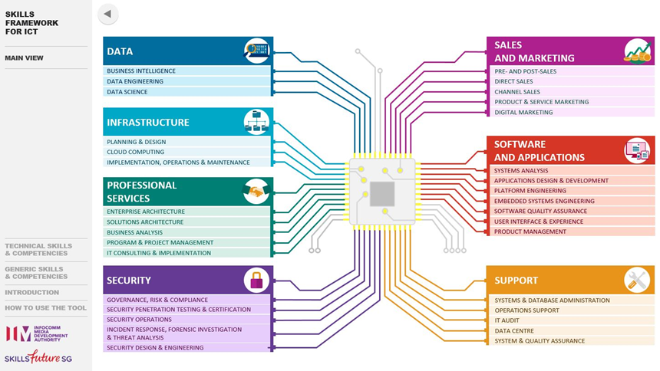

Figure 1 ICT occupational tracks

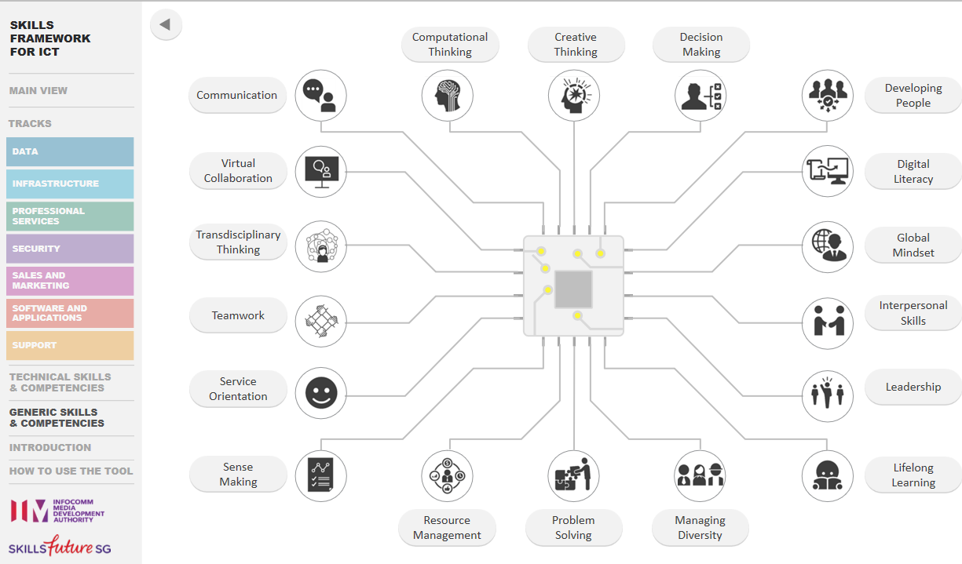
Figure 2 Generic skills and competencies
A more specific set of competencies within data science and analytics from the Asia Pacific Economic Consortium may also be useful (Figure 3).

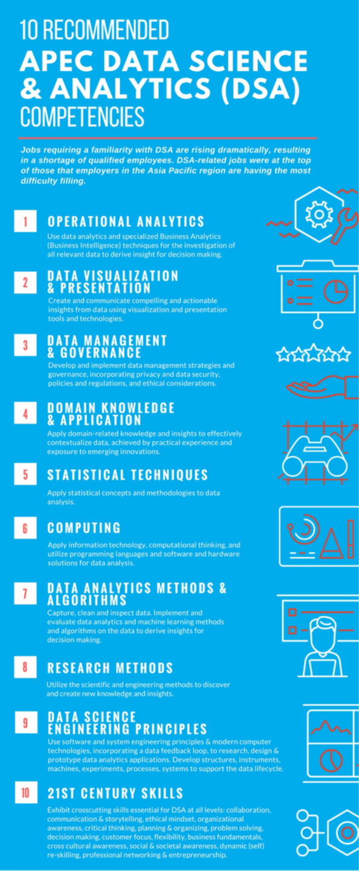

3.5 Robotics and artificial intelligence
The impact of robotics and AI has occupied the minds of many commentators on the future of work, presumably because of the potential for robots and AI to “take over our jobs”. Isolating the few evidence-led reviews from the many populist treatments is time-consuming.
Although outside the scope of this REA in terms of its format, Policy@Manchester provides a useful platform and collection of contributions in this area, including extensive coverage of how robotics and AI are core to some of the debates around the future of work, many of which were covered in Tristram Hooley’s review.
Wendy Hall’s review for the Government suggested that there were around 200 start-up companies working on AI in 2016, but cited forecasts of the impact of AI on the economy that are extravagant. PwC suggested that the UK’s GDP will be up to 10% higher by 2030 as a result of AI – the equivalent of an additional £232bn – making it one of the biggest commercial growth areas in the economy. Accenture estimated that it could add an additional £ 600bn to the UK economy by 2035, increasing the total annual growth rate in GVA from 2.5% to 3.9%. These claims seem far-fetched but are based on assumptions of impact from productivity gains and consumption-side growth due to better products as well as new entrants and new products. It is important to note that the impact of AI would not be concentrated in any one sector, nor limited to the firms that develop and produce the AI technologies. Uptake of AI will assist the automation and augmentation of processes and enhance product offerings to consumers. Thus AI was seen as becoming a ‘utility’, improving the function of digital applications and digitised functions; this is perhaps to be seen in parallel with the potential impact of ‘big data’ from advances in data science.
In terms of skills, the review suggests the UK, a pioneer in terms of AI research, will need a larger workforce with deep AI expertise as well as a much wider base of people who have lower level skills to work with AI. It recommended development of Masters-level courses, including conversion courses, as well as more PhD places, although these would seem to be a long way up the potential skills pyramid envisaged.
Closely connected to the AI review is a Royal Society report on machine learning (which is essentially a branch of AI). Although this is mostly a descriptive review, it has some focus on skills, recommending that Government, business and education ensure that relevant insights into machine learning are built into the current (computing?) education curriculum. It also suggests that in addition to the relevant areas of maths, computer science and data literacy, the ethical and social implications of machine learning should be included within teaching, not only in computing but in subjects like PSHE.
Again, there is substantive overlap here with data science – it anticipates that HE-level teaching in fields like law and healthcare will all need to incorporate the basics of machine learning. In the short term, it too suggested that the most effective mechanism to support a strong pipeline of practitioners in this area would be for a range of new Masters degrees across a range of sectors which could be used to infuse machine learning skills at a high level.
Building on its report on Machine Learning, the Royal Society (with the British Academy) have recently published an evidence synthesis on the impact of AI on work. It concludes that AI will have a disruptive influence on work with some jobs being lost, others being created and many changing. It supports a figure of 10-30% of all UK jobs being highly “automatable” but draws back from any prediction of proportions of jobs lost or created, but cites others who predict the effects on work will be felt much more strongly by those at lower educational or skill levels, suggesting that only 12% of graduate-level jobs are automatable. Based on historical parallels, the review anticipates a net benefit to overall productivity, employment and economic wealth but that this will take significant time to emerge, while some parts of the population and places may suffer adverse consequences of disruption more quickly. It highlights the potential for one overall effect of AI to be a widening of inequality. In the face of these observations, it suggests that foci for policy should include:
- Ensuring that workers of the future are equipped with education and skills necessary for them to be “digital citizens”
- Addressing concerns over potential adverse impact in terms of quality or security of employment and income;
- Meeting the demand for re-training of displaced workers (i.e. through intersectoral mobility) by new approaches to training and development;
- Introducing measures to share the benefits of AI across different communities, to offset the potential inequality impacts and maximise economic growth.

Before it was replaced by the Tech Partnership, e-Skills UK predicted that the demand for staff with big data skills would rise by 92% between 2012 and 2017 and that by 2017 there will be at least 28,000 openings for big data staff in the UK each year (at a time when there were very few qualifying with degrees in this field). Its analysis of skill requirements, however, was almost exclusively technical, focusing on different software environments and programming tools. The Tech Partnership followed this up with a further assessment in 2014 based on a survey with employers around recruitment difficulties. This suggested that generic data analysis skills were harder to find than more highly specialised data skills, while management and business acumen were the skills hardest to find among applicants to big data posts, reflecting some of the issues emerging from the Shadbolt review.
A review by the Asia-Pacific Economic Consortium parallels the industry hype around the demand for data analysis, big data and data science skills across numerous sectors has continued to grow rapidly over the last five years. It suggested that as data science and analytics (DSA)-specific and DSA-enabled jobs become more prevalent across a range of economies, competencies will need to be developed. It cited a 2017 PwC survey suggesting that in future DSA skills would be “required of all managers” irrespective of sector. DSA skills are in high demand, but their supply is critically low with employers facing severe shortages. In 2012, Gartner forecast the creation of 960,000 new DSA jobs in the Asia-Pacific region by 2015 but expected that only one third of these would be filled. Other estimates suggest a shortage of data scientists of up to a million in Asia-Pacific alone. McKinsey, it said, thinks the United States will need nearly 900,000 workers skilled in data management and interpretation by 2018, as well as 180,000 highly trained data analysts, but will potentially fall short by 150-200,000. One response to this by APEC was to propose a set of competencies for DSA, as illustrated in the first section of this REA.

3.6 Green skills
In the section on skill definitions, the concept of green skills was introduced. A cross-departmental review of skills demands for the UK in this area in 2011 concluded that the transition to a green economy will require not only skills in the low-carbon and environmental goods and services sectors, but also wider skills to help other businesses use natural resources efficiently and sustainably and to become resilient to climate change. It made some criticisms of the UK’s lag in terms of reacting to potential economic opportunities because of inertia in the skills pipeline, highlighting that energy generation was one of the few sectors that did identify specific future skills needs. The review commented that the current skills system’s focus on lower level skills, and controls on the system, were also important factors, and did not support the development of low-carbon and resource-efficient skills which were mainly cited at higher skills levels.
The OECD also suggests that, broadly, there will be demand for a range of levels of green skill, and which could be satisfied in a number of ways:
- New technical skills for new occupations and sectors that will emerge from the green economy (dark green skills) – satisfied by gearing up educational institutions and employers to provide these new skills;
- Upgrading of skillsets for those who work in industries/sectors that experience the impact of the green economy but are not at its core (lighter green);
- Greater environmental literacy in society at large (greening of consumers/users); and
- Opportunities for retraining and realigning skills in the sectors that will decline as a result of the green economy (i.e. greening of the existing workforce).
Some campaigning organisations have labelled this collectively as:
“creating and training a ‘carbon army’ of workers to provide the human resources for a vast environmental reconstruction programme”
New Economics Foundation

Based on reviews of the literature including the UK evidence base, a US study conceived four groups of technical skills in this area:
- Engineering & Technical Skills, especially for green building construction and wind turbine installations – ‘hard’ skills encompassing the design, construction and assessment of technology and essential input for energy-saving R&D projects and programmes reducing environmental impacts
- Science skills were seen separately but drawing from other bodies of knowledge broader in scope and essential to innovation, such as physics and biology, as well as implementation of the technologies.
- Operation Management skills included understanding of organisational structures required to support green activities and embed them within organisational approaches such as life-cycle management, lean production and customer relationships.
- Monitoring skills, including the technical and legal aspects of business activities, would need to be employed in relation to adherence to technical criteria and legal standards, such as regulatory requirements and environmental compliance.
This working paper suggested that changing environmental regulation triggers both the technological and organisational changes that would increase the demand for these harder technical, engineering and scientific skills, rather than purely economic opportunity and entrepreneurship.
In the UK context, in 2012 UKCES published a skills assessment for energy production and the utilities. Its focus was on the existing workforce although it did specify some areas of skills shortages. In terms of future projections, it cited Working Futures data in predicting modest growth over the next decade but suggested that other sources indicate much higher potential, especially around energy generation. Employment in wind and marine generation could increase by 45,000 (in a medium growth scenario), while up to 140,000 workers could be required to deliver the then expected nuclear new build programme through to 2025. At least 86,000 new recruits would be required in the gas, electricity and water industries through to 2025 as replacement demand. There was agreement that higher level skills (level 4+) would increasingly be required. This report seems largely to predate the expectations and projections around sustainable energy and the green economy, while its predictions about nuclear particularly fall foul of the abrupt shifts in policy direction that are prone to occur.
In that context, nuclear is one sector where workforce planning does continue to some extent. The NSSG Nuclear Workforce Assessment is produced annually, by its sponsor member organisations/partners, to provide updates on its fast-changing skills needs.
A number of other sectors and clusters also published skills assessments between 2008 and 2012, similar to the review for Energy Production and the Utilities described above, focusing on depicting the current labour force, vacancy trends and some overall numerical predictions based on Working Futures data. As such they do not lend much value to this review. In a fast-moving economy, they also tend to feel very out of date in 2018.
We asked our workshops to take a look at these issues in the context of missing elements from their own education that they now see as significant.
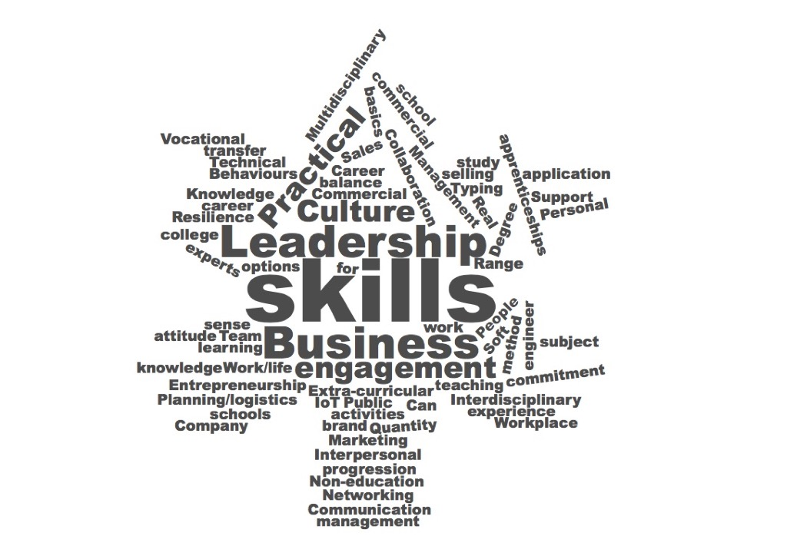

3.7 Gaps in engineering education

This topic provided lively discussion.

There was no call for a greater depth with more detailed study of topics or greater knowledge with one exception, a participant who wanted to emphasise the importance of fundamentals.

There was a wide recognition that a broader skillset would be needed in the future that would embrace leadership, working culture, team working and multidisciplinary projects. It was widely felt that these areas had not been embraced in formal education and there was support for developing the skills through extra-curricular activities with a structure to develop them and realise the learning potential.

Some of these themes were emphasised through specific gaps. One participant suggested that support in using networking tools, such as LinkedIn, was needed to help engineers in the future to get the advice and interdisciplinary learning that might have come from a professional institution meeting in the past. This reflects how requirements change and how a global working environment might bring together talents in regions without access to, for example, London-based meetings, and with individuals working across different time zones.

It is interesting to note that the missing education that the participants identified included the development of skills that are more commonly identified with subjects outside science and engineering, again emphasising the potential for diversity to change the mix available to the sector.

This included skills associated with good communication including “people skills”, “selling” and leadership. It is also interesting to see these gaps in the context of the perceived lack of public understanding of engineering -- communication is clearly not effective and other disciplines are more widely perceived as effective communicators.

Van Laar’s seven core skills for engineering (see Rapid Evidence Assessment section 1, para 2) which includes technical ability but the other six skills are those reflected in our groups: information management, communication, collaboration, creativity, critical thinking and problem solving. They also added contextual skills to the list which included lifelong learning and cultural awareness. It was clear that our groups’ experience of the balance in education did not reflect these topics with appropriate weight.

4. Emerging issues and themes
- There seems to remain a challenge over how best to define STEM or digital skills, as these are dynamic (especially for digital) being context- and time-dependent;
- What seems to be common is to envisage a hierarchy of STEM and related skills, working from the top downwards: (1) a set of core technical skills; (2) a broader set of skills needed by professionals in other sectors to make use of STEM technology; and (3) a more general digital/green/STEM ‘literacy’ in the public and society;
- There is a mismatch between a pipeline that sees STEM skills as (people with) qualifications and what industry or government can articulate in terms of its demand for skills which is seen as demand for employable people to fill vacancies;
- Industry tends to quantify its needs in terms of occupations which are less dynamic than skills (and noting that people tend to be defined by their occupation currently, and not by their skills), while education sees skills on the basis of more fixed modules of knowledge;
- Overall, STEM initiatives may be having some positive effect on the supply pipeline from education, but demographic trends and migration effects may outweigh these positive impacts, and significant barriers and bottlenecks remain;
- One of those barriers relates to under-representation of certain groups at higher levels of STEM education and especially in the STEM workforce. This in turn contributes to reluctance amongst those groups to buck the trend and pursue a STEM career (on the basis of seeing few ‘people like me’ in the existing workforce). There is also growing evidence that recruitment and selection processes into some STEM industries are not optimised to enhance diversity but limit it;
- A particular bottleneck in relation to gender exists around the requirement for A-level physics, which is the largest single ‘drop-off’ point in terms of diversity in the educational pipeline. More generally, inflexible requirements for particular qualifications may impact on the supply and diversity of those pursuing professional registration;
- There is general agreement that the requirement for high level STEM and digital skills in future will rise and in perceptions that the supply in terms of young people emerging from education will not meet that demand. This almost certainly means that more effort is needed to think about retraining of those in the workforce, including other sectors, to high levels of STEM skills;
- Workforce planning is no longer practised by most sectors in the UK – there are few attempts to model numerical demands for skills in the future (which is a change as the UK used to be considered a leading player in this respect);
- The lack of centralised thinking about future demand for skills probably also means less concerted effort to define which skills will be required (i.e. the type of skills). There is a need for more creative thinking about the types of skills that will be needed in future;
- There is a clear message around a range of contemporary employability skills being necessary along with core technical knowledge and skills – an increased supply of people with technical qualifications but who are unemployable due to a lack of soft skills would not be a good outcome for anybody;
- The type of employability skills needed is changing, with increasing understanding that there is a set of ‘21st Century’ skills which will assist in the practical deployment of core technical skills in the workplace and organisations to benefit from technological advance in a globalised economy;
- In addition, ‘digital literacy’ has gained momentum in terms of the generic skills needed in society at large to complement high levels of core technical and digital skills held by STEM professionals. Much the same applies to green skills – could the same concept be useful to underpin and contextualise engineering and other STEM industries?
- Educational frameworks should specifically include modules/learning on these employability skills, and accreditation of degree courses should specifically also cover these aspects, to integrate development of the different types of skills more fully.
5. Some existing responses and points of interest
It should be noted that these are observations made by the author of this REA in a professional and personal capacity, rather than derived directly from the published sources.
The proposed New Model in Technology & Engineering (NMiTE) degree programme will be an accelerated engineering degree at a new university (Hereford), focusing on combining creativity, design and innovation and incorporating learning in employability skills. It aims to enable qualification with an MEng degree in three lengthened academic years of study. The courses will be delivered using a ‘Sprint’ approach, integrating technical and non-technical components, with project and team-based learning a core feature to develop problem-solving and collaborative working skills, around real-world challenges sourced from industry. Key employability skills will be embedded within each engineering challenge, including communications, collaboration and contextual skills (knowledge and understanding of the ethical, economic, business, environmental and legal considerations necessary to practise engineering). One of the aspirations of the programme is to have gender parity amongst its students which will be assisted, it claims, by removal of the requirement for Physics and Maths A-levels, of which the first is a known bottleneck to diversity. Rather it will provide the necessary upskilling of students in these areas as part of the programme.
Several of the reports cited here have suggested that conversion courses at Masters level are a potential response to increase the flow of high-level skills in certain areas, especially digital. This is something currently being trialled by 27 universities in the UK, originally funded by HEFCE, BIS and DCMS in 2016-17. CRAC is evaluating the initiative and is well-placed to make some observations on progress to date. Courses have been launched in data science, cybersecurity and a range of aspects of engineering. The concept – a conversion course for graduates with degrees in other disciplines that has the outcome of a specialised engineering or computing Masters degree – does appear to work, essentially, although clearly the challenge is greater for those with a degree which ‘far’ from STEM (e.g. business) than for those with a maths or physics degree. Another idea was that these courses would enable graduates to pursue chartered status, but the PEIs have been cautious in the extreme in supporting this, currently requiring these candidates to follow individual routes to chartered status as they have studied a first degree of the ‘wrong’ type. What is perhaps more important to note is that while enrolments to the data science courses have been strong, the demand for engineering conversion courses in particular has so far been extremely low. This suggests that the demand for engineering skills of this sort is not filtering through to the adult population, who might use a conversion course to change direction, whereas it is for data science.
These two responses are essentially examples of ‘conversion’ of those on educational pathways, i.e. potentially increasing the flow in the skills pipeline by enabling the inclusion of students who made educational choices that would normally not have maintained them in the pipeline. The same concept can be used for retraining of those already in the workforce, provided that enabling mechanisms are in place for the part-time study that is likely to be necessary for such re-skilling. In many cases, it may not be in the employer’s direct interest to support this, because re-qualification is likely to lead to a change in job or career direction that may mean departure from that organisation. The introduction of the Masters loan in England should be helpful in this respect, as it will be the individual that needs to drive the upskilling rather than the employer, in many cases where a potential ‘conversion’ is desired.
A different model was posited by the authors of the Foresight report on digital skills in which unbundling of traditional degree courses in favour of credit accumulation via a range of short modules or micro courses. Again, this could appeal to those either already in the workplace seeking to change direction to an ICT professional career, or for those in higher education who did want to commit to a traditional computer science programme.
Finally, on barriers to diversity, some of CRAC’s own work around graduate recruitment may offer some additional insights of interest. Recruitment industry knowledge suggests that adverse impacts occur in relation to candidate diversity due to several features of conventional graduate recruitment processes. These range from the well-known (such as the need to use diverse imagery in promotional collateral) to less well-known such as the benefit of “neutralising” language to widen appeal and the impacts of certain types of assessment. For example, numeracy testing (at a high level) is included in some graduate recruitment processes and is known to limit gender diversity. Group and presentation exercises are known to favour white, middle-class males and especially those from private education with high levels of self-confidence. There is a growing array of evidence within the industry as some companies are introducing alternative assessment mechanisms in order to diversity their intakes in order to enhance staff diversity and inclusion and to foster social mobility. CRAC has recently undertaken a study for the Royal Academy of Engineering looking at engineering sector recruitment practice, in order to consider the extent to which these are currently limiting the diversity of graduate engineers entering the engineering workforce in the UK.

6. The skills mix of the future – requirements, provision and resources

In our final Phase 1 workshop question we asked participants to think about the future and make some predictions for changing technologies and the skills needed to support them.

The Future; word cloud from first phase of workshops
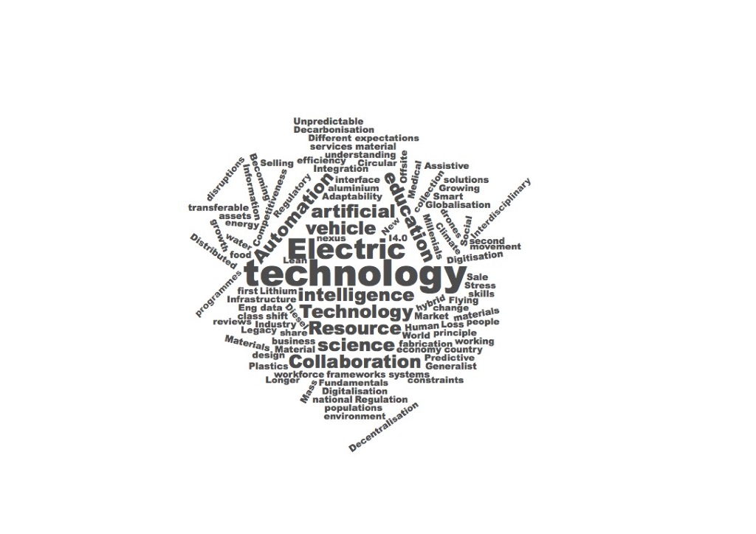

The discussions on the future skills needs were wide ranging, reflecting the different sectors and geographical mix.

The dominant word-cloud topics were technology, intelligence, automation and collaboration. Electric was so important and consistent in the automotive group that it is in the spotlight.

Environmental themes are clear but use more diverse terminology including decarbonisation, raw materials, regulation and legacy. The apparent contradiction between distributed manufacturing, already possible through local 3D printing and with potential for greater personalisation versus more centralised manufacturing off-site in the construction industry was also raised in the discussion session.

The sense of disruption and a skillset that is adaptable to rapid and significant change is identified specifically and is set behind many of the other terms. Different business models also came up, predominantly but not exclusively in the digital area and this included a shift from delivering “things” to delivering solutions and services, a perception that models for risk sharing could continue to change.

This first look at the future, without past case studies to prime the discussions, was intended to shape the second phase of work and has provided that platform. It is interesting that healthcare, the environment and the dominance of digital technology, including AI, were less obvious in the word cloud, principally because these were omnipresent themes rather than issues for discussion. There was general discussion of materials without specifically describing, for example, nano-materials.

With this background, we took the participants in the second phase of workshops on a more structured discussion jouney into the future which is described in more detail in Appendix 4 with summaries of the discussions included as Appendix 3 for each individual session.

The thinking was baselined by asking participants to rank a list of themes in order of importance, outline their own experience of disruptive change so far and what they anticipate by 2050 and to describe the most relevant skills with ideas on how these might be provided through the education and skills system. We finally discussed who should pay for the up skilling and/or reskilling.

The initial list of themes provided, which attendees were invited to augment if they thought something important had been missed, included Artificial intelligence, Internet of Things, Climate change, Personalised healthcare and Clean water. Climate change and AI dominated the rankings, in part because they were seen as foundations for the other topics that captured the real priorities rather than the opportunities or symptoms that resulted from them.

There were additions, as captured in the word cloud, including changes to manufacturing

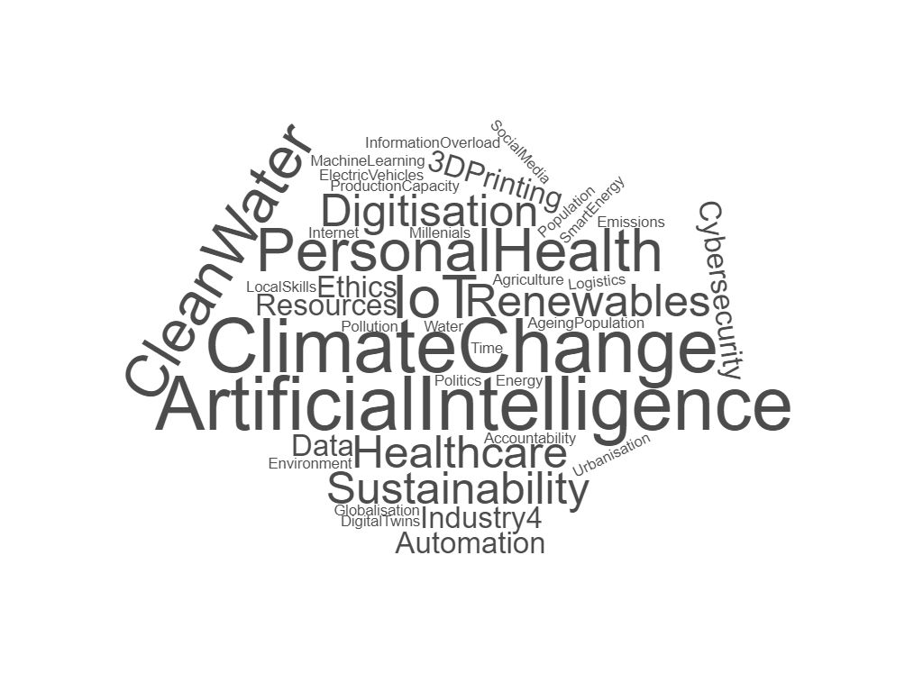

Attendee priorities at outset of Phase 2 Workshops

Asking attendees to outline their own experience of disruptive change so far the clear change was connectivity, described in the Word Cloud as Mobile, Internet and Social Media. There were some unexpected additions. One delegate from the Defence Industry named GameBoy.

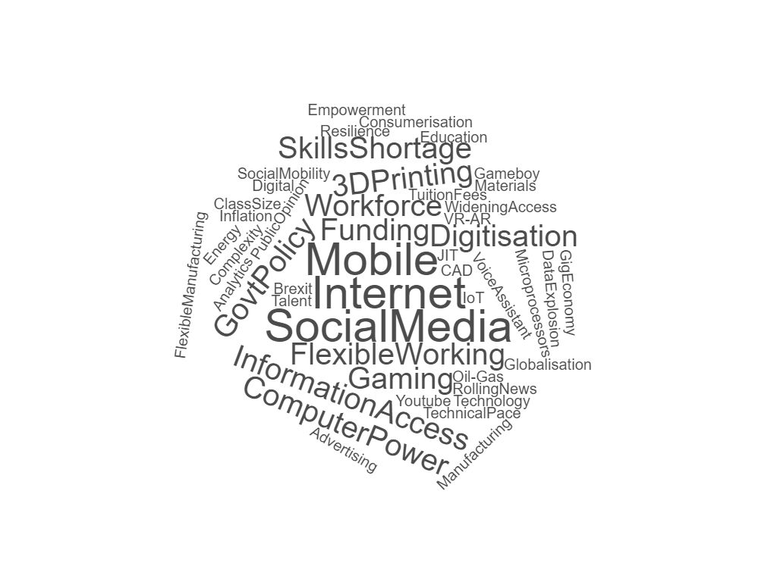

Attendee experience of disruption over the past three decades.

This was not in the context of wargaming or some other advanced simulation but rather it came from the insatiable demand for semiconductor devices in a consumer product that changed the ability of the defence industry to buy the components it needed and led to greater use of commercial components and stockpiling to support the long service life of defence equipment, which could be several decades compared with a six to twelve month product cycle for consumer electronics. Other themes included skills shortages, globalisation and specific education themes such as widening access and tuition fees.

The Gig economy was cited but working patterns came up more in the discussions of the future than recounting the past. This was an interesting question to pose to a group of 17 and 18 year olds for whom the present with microprocessors all over the place, digital assistants and universal connectivity represent the norm. This group also highlighted social issues like high housing costs and the political confusion of Brexit. Government policy did feature in the sessions with working-age attendees as well, both directly and in some of the topics expressed in education, funding and regulation. At a time when the sales of diesel vehicles in the UK had dropped by 30% in one year amid confusion over local and national charges based on diesel pollution and the funding for education had shifted dramatically in apprenticeships and undergraduate courses, it is perhaps surprising that Policy was not higher up the agenda.

As we moved into the questions on the future there was a rich set of themes.

The big disruption expected by 2050

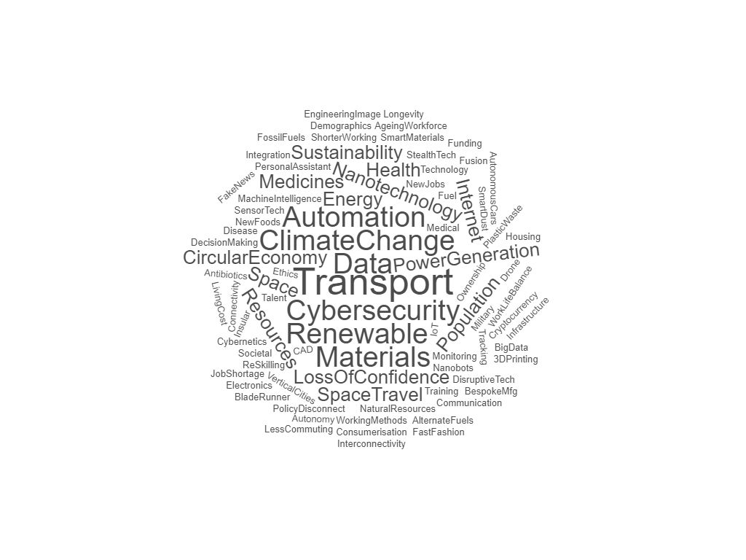
Transport was a big theme, directly cited and in topics like space travel which our teenage attendees offered as a solution to over population. The use of big data was assumed to underpin much of the change and there was a clear identification of materials, including specifics like nano-technology, smart materials and fuels. Health issues did feature including the ageing population, antibiotic resistance, disease and new foods. This was a very crowded list and serves to emphasise just how important inter-disciplinary working will be in the future. The anticipated changes are really quite practical, not assuming that everything will happen in a data-driven virtual reality but that data analysis will underpin change when used well and not compromised through cybersecurity or trust issues.

When asked to translate those changes into the skills needed to deliver them, four areas dominated: people skills (communications, resilience, leadership; empathy); creative thinking (innovation, problem solving); entrepreneurship; ethics.

The skills needed for 2050
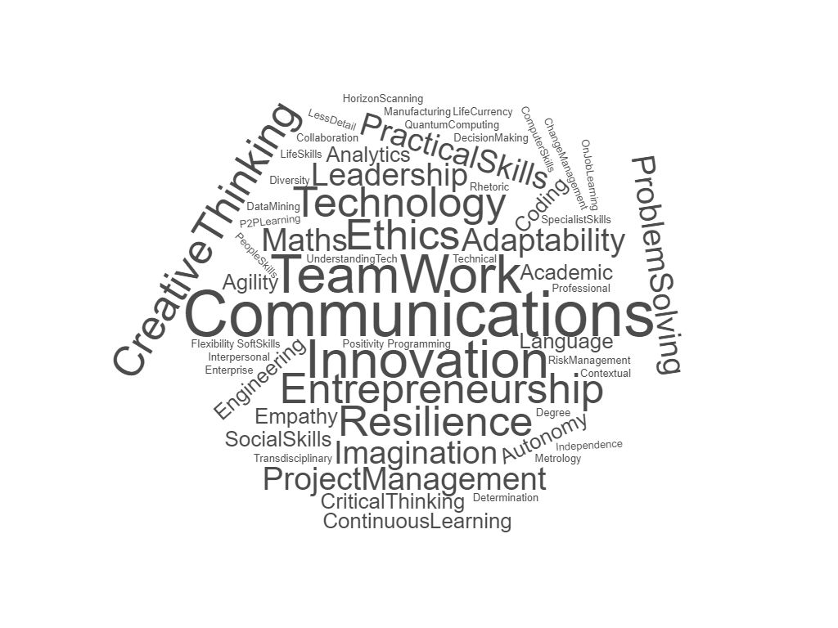
Flexibility and continuous learning were also there, reflecting the need to update skills continuously and be prepared for jobs of the future that change dramatically. The academic learning and practical skills are also on the plot and it was appreciated that implementation will require those but they were not allocated into different, distinct streams in the way apprenticeship and university routes have been over the past decade. Recalling the word cloud in section 3.7 where we looked at what attendees viewed to be missing from education today there is a further progression into the so-called “soft skills”

Topics missing in today’s education

Underpinning these results was an understanding that knowledge is already on tap, although there was some significant discussion as to how far that would go in an AI-fuelled world, whether code might be written, for example, by another piece of code rather than by a person or team of people!
The work on missing elements in education from the first phase had already guided us to suggest that there is significant potential to recruit from alternative sectors and provide the appropriate engineering knowledge through a mix of training and/or access to the knowledge base. The current model in engineering assumes a pipeline of individuals building a large resource of engineering knowledge, whether through a university or apprenticeship route, which can then be augmented by people skills, management, communication and business, to provide that broader skillset in a career. It is a T shape where the technical knowledge has to be there before the other elements, the horizontal part of the T, can be added. Hence the “leaky” pipeline of talent with no potential to top up later. Key qualifications in that pipeline are massively skewed towards male participation, including A Level physics with a 4:1 male-female ratio and computer science with a 9:1 ratio.
The work in the first phase suggested that there is already potential for intersectoral recruitment where the skills that make the horizontal part of the T are already in place through education or work experience and the missing engineering elements can be added later, opening up the potential to recruit a far more diverse workforce and to enhance that diversity faster than waiting for changes in school-age education to feed through.
The skills suggested by our participants in the workshops match those already identified in the Rapid Evidence Assessment although they do go further, suggesting that three pillars of skills, (people skills, creative thinking, entrepreneurship) alongside a pillar of core technical knowledge and underpinned by ethics could be more relevant to the future with the potential to add layers of technical knowledge in the future as technology changes and the use of artificial intelligence creates opportunities to exploit the existing knowledge base.
The correlation with Figure 2 in section 3.4, the generic skills for IT, is reassuring.
It is surprising though that digital skills did not feature more prominently, particularly when reflecting on section 3.4 and 3.5 or the Rapid Evidence Assessment. Exploring further, nearly all participants saw those digital skills as a central pillar in all education and in future jobs. This was a given.
It was apparent from the discussions that these wider skills would support interdisciplinary working and a shift to the Gig economy, which has already been seen in IT, where teams from different organisations or no organisation at all tackle challenges.
We explored the questions related to who should provide the future education and who should pay with each group. Our attendees, almost universally, saw a joint effort to educate, up skill and reskill the population and saw it as an essential part of remaining economically active as individuals and globally competitive for the UK. There was an expectation that the state, individuals and employers should all contribute but also a realisation that the Gig economy could reduce the reach of employers in a traditional sense.
There was a clear view that the process needed to be more collaborative and continuous rather than the current separation between the State and Employers with the principal links between the two being tax, including the apprenticeship levy. There was an acceptance that individuals could be expected to fund their advancement so long as mechanisms were there to support them, both through easily accessible online learning and through access to finance, including loans, for larger investments. The apprenticeship levy was viewed as a missed opportunity and a system with pooled funding, whether through trade associations, regional or national government, should be available to support education and skills training more widely than just large employers.
Attendees fully expected universities, colleges and employers to be part of the training provision, and, when prompted, professional bodies too. The potential to add layers of technical skill, both as part of upskilling and provide knowledge and skills to a more diverse workforce could be provided by any of these groups but would represent something of a shift from the position today where mature student numbers at universities have fallen significantly and the bulk of professional bod activity is based on sharing knowledge within the existing engineering workforce rather than extending outside to increase the pool.

Finally, a significant point for online learning came from our year 13 teenage students at the JCB Academy. They rejected online learning, which was a surprise but probably should have been. The school system in the UK, particularly in England, has become more focused on imparting and testing knowledge in a disciplined school environment. But, these students were all experts in online learning outside school: every one of the students had used YouTube or other online products to learn make-up tips, use or fix equipment or to support learning in their lives. They did not see the relevance of the online tools to their academic learning. If the UK is to thrive in a technology-dominated future with real global competitiveness, online tools will need to be embraced in education far more effectively than simply putting lectures online.

Appendix 1: Phase 1 Workshops – methodology and reporting

Concurrently with the Rapid Evidence Assessment, a series of workshops was undertaken in June and July to build a snapshot of education and future opportunities from a user perspective. The workshops were organised both to provide useful insight in themselves and as preparation for the follow up work in Phase 2 of the Talent 2050 Programme.

The first three workshops were held in Sunderland, Edinburgh and London with the support of local universities, business and local government. The support from Edinburgh Napier, Sunderland and London South Bank Universities was an essential part of the workshops in providing facilities and bringing together a cross-section of participants from their local communities.

We aimed to get different perspectives in background, sector and career stage. Some senior individuals from public and private sectors, a trade union, education and professional bodies were joined by early career stage professionals and researchers to bring a fresh perspective to the discussions.

Each workshop participant received a brief in advance on the topics to be discussed and were briefed on the mixed post-it and discussion format and the broader context for the project. The post-it exercises were conducted either individually or in groups of three. Different sectors of engineering were reflected in each group, with a greater emphasis on the built environment in Edinburgh, automotive manufacturing in Sunderland and a mix of energy, defence and the creative technology, including professional bodies and a trade union, in London.

In each case the University staff added a broader perspective including a greater emphasis on digital skills. Some work was individual with some in groups of three, fourteen groups altogether.

Reporting
The results from the three workshops, and a total of 14 groups within them, showed significant correlation in major themes coupled with some distinct regional priorities, particularly notable in the emphasis on apprenticeships in the North East of England. This is perhaps not surprising in an area where Schools North East identifies that 10% fewer students in that region will gain a place at University at 18 when compared with London and affluent counties like Surrey and Hertfordshire.

The exercises worked well but participants were keen to qualify or elaborate upon their answers rather than give a single word, despite much encouragement. With that in mind, the automated Word Cloud presentation, using Wordclouds.com, gives an initial flavour of the responses without bringing out some of the key trends identified and pursued in the follow-up discussions once responses had been grouped.

The workshop results are reported here for the four topics discussed and crossover is noted which includes links between the attractions into engineering and the barriers to entry, most notably in salary and access to good information.

The four areas for discussion provided to participants were:

Attraction to engineering. Three words - what attracted you or why it is attractive?
Barriers. Looking at talented people you know or have known – what stopped them from developing engineering skills?
Education. What was missing in formal education that you have needed or seen others need?
The Future. What could change dramatically? Prompts given were the scale of online retail, semiconductor industry etc. We asked about the skills needed for that change? Type of skill? Practical, academic, mathematical, social science?

Common themes arose through the workshops with some distinct local variation, particularly reflecting the different school systems in Scotland and England and the far greater emphasis on apprenticeships in Sunderland and the North East of England more generally. This served to emphasise that some recommendations from the study will appropriately be at a national or UK level but others will have more impact regionally and locally.

Appendix 2: Sources quoted in Rapid Evidence Assessment, July 2018

Numbering corresponds to order in which sources are quoted in narrative (gaps occur in the numbering due to multiple references to some sources)

- Jobs and growth: the importance of engineering skills to the UK economy, Royal Academy for Engineering, December 2012
- Four steps to define digital skills, Readie/NESTA, February 2018 https://readie.eu/resources/four-steps-to-define-digital-skills-with-frameworks-you-can-use-and-adapt/
- The relation between 21st-century skills and digital skills: A systematic literature review, E. van Laar et al., Computers in Human Behavior v.72, March 2017
- Greener Skills and Jobs, OECD Green Growth Studies, OECD/Cedefop, 2013
- Engineering UK 2018: The state of engineering, Engineering UK, February 2018
- Delivering STEM (science, technology, engineering and mathematics) skills for the economy, National Audit Office, January 2018
- Roehampton Annual Computing Education Report, University of Roehampton, June 2018
- Shut down or restart? The way forward for computing in UK schools, The Royal Society, January 2012
- ‘A longitudinal evaluation of the impact of STEM enrichment and enhancement activities in improving educational outcomes’. Banerjee, P.A., (2016), International journal of educational research, 76 (1), pp. 1-11
- Career guidance and the changing world of work, T. Hooley. In ‘Education and technological unemployment’, Peters, M.A. et al. (Eds), Springer, in press 2018
- ‘Skills Panorama’, Cedefop: http://skillspanorama.cedefop.europa.eu/en
- Delivering STEM skills for the economy, House of Commons Committee of Public Accounts, June 2018
- Skills Shortages in the UK Economy, The Edge Foundation, January 2018
- Skills Forecast: key EU trends to 2030, Cedefop, June 2018 http://skillspanorama.cedefop.europa.eu/en/analytical_highlights/skills-forecast-key-eu-trends-2030#_demand_for_and_supply_of_skills
- Helping the UK thrive, CBI/Pearson Education and Skills Survey 2017, Confederation of Business & Industry, July 2017
- In perfect harmony, Improving skills delivery in England, Confederation of Business & Industry, January 2018
- Working Futures 2014-2024, UK Commission for Employment & Skills, April 2016
- The Future of Skills: Employment in 2030, NESTA and Pearson, August 2017
- Does the EU need more STEM graduates? Teknologisk Institut, Denmark, November 2015
- Employer Skills Survey 2015: UK results, UK Commission for Employment & Skills, May 2016
- What type of future workforce will the UK need? Foresight / Government Office for Science, October 2013
- New Skills Agenda for Europe: Working together to strengthen human capital, employability and competitiveness, European Commission, June 2016
- Digital skills and inclusion - giving everyone access to the digital skills they need, Department for Digital, Culture, Media & Sport, March 2017 https://www.gov.uk/government/publications/uk-digital-strategy/2-digital-skills-and-inclusion-giving-everyone-access-to-the-digital-skills-they-need
- Digital Skills for the UK Economy, Department for Business, Innovation & Skills and Department for Digital, Culture, Media & Sport, January 2016
- Shadbolt Review of Computer Science Degree Accreditation and Graduate Employability, Department for Business, Innovation & Skills, May 2016
- Building a Britain fit for the future, HM Government, March 2017
- Sector insights: skills and performance challenges in the digital and creative sector, UK Commission for Employment & Skills, June 2015
- Lifelong digital skills development, current picture and future challenges, Foresight / Government Office for Science, June 2016
- Strategic Skills Assessment for the Creative Industries, Creative Skillset, 2010
- Skills Framework for ICT, SkillsFuture Singapore: https://www.imda.gov.sg/cwp/assets/imtalent/skills-framework-for-ict/index.html
- Data Science and Analytics Skills Shortage: Equipping the APEC Workforce with the Competencies Demanded by Employers, Asia-Pacific Economic Cooperation, 2017
- On AI and Robotics- Developing Policy for the Fourth Industrial Revolution, University of Manchester, 2018: https://policyatmanchester.shorthandstories.com/on_ai_and_robotics/index.html
- Growing the Artificial Intelligence Industry in the UK, Department for Business, Energy and Industrial Strategy and Department of Culture, Media and Sport, October 2017
- Machine learning: the power and promise of computers that learn by example, The Royal Society, April 2017
- The impact of artificial intelligence on work, An evidence synthesis on implications for individuals, communities and societies, The Royal Society & British Academy, September 2018
- Big Data Analytics. An assessment of demand for labour and skills, 2012-2017, e-skills UK, January 2013
- Big Data Analytics. Assessment of Demand for Labour and Skills 2013–2020, The Tech Partnership, October 2014
- Skills for a green economy: a report on the evidence, HM Government, 2011
- Green skills, National Bureau for Economic Research, Working Paper 21116, 2015
- Energy Production and Utilities: Sector Skills Assessment 2012, UK Commission for Employment & Skills, 2012
- Nuclear workforce assessment 2017, Cogent/Nuclear Skills Strategy Group, 2017

Appendix 3: Phase 2 Workshops – methodology and reporting
The six workshops in the second were held during November and December 2018 in Sunderland, Rocester, Glasgow, London, Birmingham and Southampton, hosted by Universities, business and a school. In addition to individuals from public and private sectors, education and professional bodies we worked with a group of final year secondary school students to hear from those who will be actively productive in 2050. For this new phase we prompted discussion by sharing in advance case studies of major technology, market and job disruption in photography and recorded music which saw sectors created and companies destroyed within three decades, and in logistics.

The Workshop Briefing Pack and a sample agenda are included as Appendix 4.

Results were captured and summarised for each session before drawing them together with the research in the Rapid Evidence Assessment and the Phase 1 results. In this follow up work our goal was to drive thinking beyond incremental change into real disruption and to capture predictions of future priorities, the skills needed to for those priorities and to identify how the education and skills system could deliver on the predictions and aspirations.

A summary of the discussions is included on the following pages to give background to the earlier word clouds.

Individuals attending or contributing through the Liaison Group came from the following companies and organisations:
Ripmax; Institution of Structural Engineers; London South Bank University, Engineering Council, BSI Group; Policy Connect; the Greater London Authority; National Careers Service; Engineering Development Trust; Solent University; Scott White and Hookins; Oxford Innovation; Heman Dual Controls; NATS; Hands of the Future Project; HS2; University of Wolverhampton; University of Derby; Thales; Howden; Clyde Bergman; SSt Sensing; Bridge of Weir Leather; Devro (Scotland) Ltd; City Holdings; Bouygues; EDF; Laing O’Rourke; Scotland TranServ; Atkins; Jacobs Engineering; Glasgow Caledonian University; JCB Academy; Accenture; CA Group Ltd; CDEMN; Dyer Engineering Ltd; Expert Tooling; Festo Didactic GB; HYDRAM; Maats Tech Ltd; North East Automotive Alliance; Nissan Motor Manufacturing (UK) Ltd; Aston University, BAME Apprenticeship Alliance; Rolls Royce; New Model In Engineering and Technology; Pearson; Barclays; Indian Institute of Information Technology (Bangalore); Institution of Mechanical Engineers;

Views captured were from the individuals rather than necessarily reflecting company views or policies.

Phase 2 Workshop: London South Bank University, 21st November 2018
- What’s the most important factor that you think will make the most impact in society and that engineering will have to deal with?
The key themes highlighted as making impact were around environmental issues, followed by ethics, digitalisation and the internet of things (IoT), and personal health.
When pushed to pick the top issue, there was consensus that environmental impact will be the most important factor that engineering will have to deal with. This ranges from climate change and resource depletion, to smart energy, clean water and in general sustainable development.
Data and ethics were next, and discussion focused around what would be the accepted societal norms. For example, would there be pushback against assistants such as Alexa, which are constantly listening; and with social media and internet companies, will society continue to accept that they have to give away personal data for something in return?
- What was the greatest disruption that you have seen in your area of expertise since 1990?
Overwhelmingly the internet and empowered consumers were considered the biggest disruptions since 1990. The internet has empowered people, whether they are consumers or students, which has led to change in human behaviour, in terms of expectations of service levels or instant gratification.
This has been enabled by constant access to information and data via the web, mobile and social media. In government, it has resulted in the ability to quickly spread misinformation by those in search of political gain. It has transformed education, switching the power from teachers and academic staff, to students who are more empowered to demand value for money for their teaching.
- What do you expect to be the biggest disruption by 2050?
Two key threads emerged: one around technology and its implications, the other around climate and human behaviour.
On technology, the penetration of artificial intelligence (AI) across industries would lead to the world of work changing dramatically, and possibly creating new jobs. There would be an acceptance of disruptive technology and it’s use for decision making. As a result, there would also be transformation in materials used to develop new technologies and products. All these changes would lead to a massive need for re-skilling.
Climate change and renewable energy would be the other major disruption. In terms of human behaviour, the circular economy would have great impact, and with all the technology, there may also be impact on mental health due to the implications of autonomy and longevity enabled by advances in medicine.
- What could change dramatically and what are the skills needed?
Significant emphasis was placed on soft skills being essential to address the new grand challenges that would impact society. It was though that information can be easily obtained and that tech skills could be easily learned. But context was important so understanding social skills and ethics would be more important. Soft skills include empathy, resilience, leadership, creative thinking, entrepreneurship, and understanding people’s expectations and behaviour. Ethics and diversity also feature strongly.
There was however mention of skills such as maths, data mining and metrology.
- Who pays, who educates?
While there’s a thought that government and industry need to work together better (they’re not at present), it was widely thought that those who benefit should be paying or contributing. Hence funding could be part industry, part personal (the individual or student), and part government. There is already a trend toward the individual paying for some massive open online courses (MOOCs). There was also a thought that learning should move away from fact-based learning, and that there would be a hybrid between academic and corporate learning.
-------------------

Phase 2 Workshop: Birmingham, 27th November 2018
- What’s the most important factor that you think will make the most impact in society and that engineering will have to deal with?
The environmental agenda and technology dominated this section of the discussion. Climate change, clean water, agriculture and depletion of natural resources are high on the agenda. In all areas of engineering there will also be a conscious awareness of impacts on sustainability – such as in building a railway, there’ll be a need to consider how to reduce earthworks for example. There will also be more of a focus on inter-disciplinary working (for example engineers and architects working together) and a holistic approach to design, enabling better outputs.
Artificial intelligence will be a key driver of change and will have impact in areas like personal healthcare as well as agriculture. The internet of things (IoT) is another enabling technology for the changes ahead.
- What was the greatest disruption that you have seen in your area of expertise since 1990?
Advanced manufacturing, 3D printing and advances in materials (eg. carbon fibre) are considered to have been the most significant disruptions over the last 30 years. Advances in computing and the introduction of automation has changed the way the industry works. For example, 30 years ago, people were working on drawing boards, now computer-aided design tools have transformed design and enabled simulation capability and even the development of digital twins.
In manufacturing, significantly flexibility has been enabled by computing and the internet. There’s no need to hold huge quantities of stock, with the advent of just-in-time manufacturing and advanced logistics capability in the supply chain.
Another major change is the gig economy enabling flexible working. It was noted that we don’t need desks anymore. However, this has also brought challenges, such as how do you provide work-based learning in a gig economy?
- What do you expect to be the biggest disruption by 2050?
The way we move around cities and work will change dramatically, as will the way people learn. We’ll see significant behavioural change – there will be a lot less people in cars and taxis, and much less ownership of things; people will also move less and are more likely to stay in one place. Car ownership could disappear, there may just be transport pods.
There’ll be more demand for new skills, and if there’s not enough investment in skills, those with the right skills will be able to demand where they work, enabled by flexible working.
Loss of confidence in big technology, and lack of understanding of technology were also cited as factors that may disrupt over the next 30 years. Facebook and the lack of scrutiny of information was quoted as an example.
In terms of technology, one group referred to ‘smart dust’ as being a major disruptor by 2050 – this refers to tiny connected devices everywhere collecting and transmitting data about the environment. In manufacturing, mass personalised production may be possible using 3D printing (this can already be done with a major brand of training shoes for example).
- What could change dramatically and what are the skills needed?
A focus on practical real-life skills rather than academic specialisation seemed to be the general consensus within the group. This doesn’t mean to say there shouldn’t be specialisation, but there needs to be a mix of academic and practical skills. People should be able to understand the fundamentals, even if they then broaden their area of work.
There was a feeling that schools specialise too early, and maybe we need more of an American model of broad-based study followed by specialisation as and where needed. There was a line of thinking suggesting that engineering education is not aligned with then needs of the workplace; one comment highlights this: “I learned most of my engineering skills after graduating”. In addition, very few engineers have the ability to convince people of an argument or proposal verbally, hence communications and inter-disciplinary skills will be vital in the next few years, especially if more and more flexible working is adopted among teams.
Social, communications and team skills were considered the most important skills to address the changes expected in the next 30 years.
- Who pays, who educates?
The new model for funding would have to be much more collaborative. In the current model, the government pays for a major part. But with a shift to flexible working and more of a gig economy, it will be left to the individual to chart his/her learning and skills development. The dilemma however will be that the individual may not be able to fund it, so there needs to be more participation from industry and employers for skills development.
-------------------

Phase 2 Workshop: Solent University, 27th November 2018
- What’s the most important factor that you think will make the most impact in society and that engineering will have to deal with?
Climate change, sustainability and an ageing population were the key factors considered to be most important in this group. Environmental and survival issues (eg. clean water, public health and ‘existential’ problems) were most important. With the ageing population, the questions of how you keep adults working longer and how to keep them employed was raised.
Consumer awareness was also highlighted – everyone will be a consumer, whether you are buying things or services, an employer or employee.
Some suggested AI and technology as a whole are becoming too much, and that living in an ‘artificial’ world was not that desirable. Personalised healthcare was considered least important.
- What was the greatest disruption that you have seen in your area of expertise since 1990?
Two key themes emerged: one was clearly around technology, but another one not discussed in any other workshops was around policy disconnect, in terms of both funding and legislation.
The internet, data and communications were cited as major disruptions, enabling huge amounts of access to knowledge and knowledge transfer. Computer aided design and automation were also mentioned. It was noted that there’s a tendency to over-complicate things using technology.
Policy development not aligned with environmental or workforce needs were particularly significant over the last 30 years. The rise and decline of diesel car sales based on tax regimes is an example. There has often been well meaning legislation trying to meet ethically perceived good targets, but poorly thought out in terms of its detail and implementation.
Another comment was the loss of the ability to use ‘gut feel’, or instinct – since every argument or proposal cannot needs lots of data to back it up, which can slow down the process of innovation.
- What do you expect to be the biggest disruption by 2050?
While automation, AI and climate change were considered as disruptors, there was significant discussion around skills, a skills gap, and the need to have a skills currency.
Climate change would be a big driver in shipping, indirectly impacting how we will have to consume things. The logic is that the continual need to reduce pollution will mean having to build larger and slower ships. This means goods will take longer to ship, say from China to Europe, and that means consumers will need to change their mindsets, in terms of how quickly their products can be delivered.
The gig economy will also be transformative for all sectors, and engineers won’t be exempt. As the workforce ages, engineers made redundant will be forced to take whatever they can. In turn, it will be a struggle to keep the workforce trained to deliver what is expected, hence a skills currency may need to be adopted.

- What could change dramatically and what are the skills needed?
More autonomy, with smart homes, smart transport, coupled with automation, could result in more free time and leisure time, so how this is addressed will also need to be considered – for example, can it be utilised to train new skills or additional study?
Quantum computing also has the potential to be used for both good and bad – for example the sheer computer power means a computer can crack any code in 30 seconds and hack a bank account. Hence a paradigm shift in finance and currency is needed with a totally different way in which we transact. We’ll need to see value in a completely different way.
Education may need to be radically transformed to meet the skills needs. The question was raised as to why we force young people to learn at 16 - 18 years old the way we do now, and why does learning have to stop at 21? That culture needs to change to address the need for lifelong learning. Some participants in the workshop suggested that education is already at a stage where it doesn’t deliver what students need. We need to be able to think about education across all age groups. The whole time-line of an individual’s life needs to be addressed, if he or she is going to be working longer, and a new way of acquiring and valuing an individual’s skills needs to be created.
In terms of specific skills, it was though accessing facts will be easy, so skills to filter information will become important. In addition, skills such as digital literacy, communication, ‘horizon scanning’, resilience, team-working, flexibility and entrepreneurship will all become essential. Despite access to information, where technology de-risks a lot of processes, it will be essential for individuals to have the skills to understand the fundamentals of engineering and what is going on, in case the technology fails. People will always need to be ahead of automation in terms of skills.
- Who pays, who educates?
Multiple groups will be responsible for funding, and it will need to be looked at over an individual’s whole lifetime. Participants said the apprenticeship levy has been a disaster, and we’re somewhat imprisoned by legacy systems.
Several suggestions were made on funding – loan schemes similar to the way undergraduates are currently funded, or industry trade associations collectively creating ways to fund apprentices or training, and a national insurance style system was also mentioned, where individuals contribute and the state tops up and provides structure.
Overall, a collaborative approach is needed – some responsibility resting with the individual, supported by industry and government.
-------------------

Phase 2 Workshop: Sunderland, 5th December 2018
- What’s the most important factor that you think will make the most impact in society and that engineering will have to deal with?
Climate change and economic sustainability were the top considerations in this part of the discussion. On climate change, emissions and clean water were important. Electric vehicles will also have an impact, given the region’s dependence on the automotive sector.
A major concern in the local context was economic sustainability – with factors ranging from energy cost and availability, to production capacity and being able to continue to provide employment for the local workforce. A big concern was the fact that a lot of the Sunderland economy, while anchored by a major motor manufacturer, is based on an ecosystem of SMEs, and that growth and scaling of the businesses is a big consideration.
Technology factors like digitisation, AI, IoT, while mentioned, were not considered particularly important compared to the people, the environment and health.
- What was the greatest disruption that you have seen in your area of expertise since 1990?
The general mood was that everything has changed – from education, and the number of people going to university (reference to number of unconditional offers for university places this year), to technology, access to information (internet), and the way in which work is delivered (in particular, ‘agile’ workflows). It was also noted that the workforce has become much older – people who might have started out in the last 30 years are still working.
The commercialisation of universities (and the fact that there are so many of them) was highlighted as a big change over the last 30 years, as is the thirst for knowledge, enabled by technology and access to information; however on the flipside of this is the depth of knowledge is often shallow as we use the technology to get the information we require.
The apprenticeship levy was also mentioned, with comment that some degree apprentices don’t really need degrees.
- What do you expect to be the biggest disruption by 2050?
Education and learning dominated most of the discussions again, and in responding to this question, various aspects of the way we will learn were highlighted. Blended learning or stimulated e-learning were particularly considered the biggest changes expected in the future; there would be a mix of delivery mechanisms, including modularised and online. In addition, there will be less reliance on a physical presence in an institution. Most thought that universities will need to change and adapt.
The other main disruption could be the demise of fossil fuels, availability of lithium, and battery materials technology, and the impact these would have on the local economy.

- What could change dramatically and what are the skills needed?
A healthy discussion again focused on personal, communications and leadership skills; this includes agility, adaptability and emotional intelligence. Manual and practical skills are also necessary, since some thought that 19-20 year-olds don’t want to do some of the manual tasks that the older generation have grown up doing. Other necessary skills would be around building trust
The way we deliver learning will have to change. One comment was: “The way we teach and measure skills and learning doesn’t match the needs of the modern workplace.” Personalised learning will be increasingly important – especially as viewed from a current new generation who have broken away from past ways of learning. One suggestion was to have recommendations for learning in much the same way as Amazon currently makes buying suggestions based on past history or search history.
Consumer customisation will also be a major change: as an example, Nissan and motor manufacturers may have to implement processes where each product is customised according to an individual’s needs.
- Who pays, who educates?
The responsibility has to be a collective and collaborative responsibility, between the individual, industry, government and educational establishments. There’s a need for practical, professional and academic achievement. It was thought that the current education system is outdated for a world that’s changing fast – and that the educators are being measured on outcomes set by themselves, rather than what the workplace needs.
On the question of who pays, distinguishing between what’s relevant for the role versus what’s relevant for the individual is essential – for example, the individual pays if it’s something for their own personal development, while the employer should pay for training that’s required or relevant for the job. However, it was noted that it is sometimes useful for employee retention for employers to occasionally approve non-relevant training.
-------------------

Phase 2 Workshop: JCB Academy, 6th December 2018
The group at the JCB Academy were all year 13 students taking a BTEC in engineering with nearly all or the 25 students taking maths A Level, around half taking Physics A Level and one of each taking English and Design. They will have been 17 or 18 and around one third were female. They had not previously seen the background notes or agenda.

- What’s the most important factor that you think will make the most impact in society and that engineering will have to deal with?

Split into eight groups of three, the priorities from the list given were environmental across most groups including climate change and clean water with the addition of renewable energy.

The other additions were additive manufacturing and housing, also expressed as overpopulation.

- What was the greatest disruption that you have seen in your area of expertise since 1990?
Looking at the changes that had impacted these young people’s lives over the past two or three decades it is important to remember that their experience of change is much shorter! The big changes they reported were dominated by connectivity and internet related systems including gaming, social media and personal assistants. They appreciated that microprocessors had been an important part of enabling the change but also pointed to political issues including Brexit and inflation with a perception, driven largely by fear of high housing costs, that prices had increased.

- What do you expect to be the biggest disruption by 2050?
When asked to project forward to 2050 the Academy group thought about transportation in the broadest sense including space travel and exploration, seeing this as a possible solution to overpopulation. Sustainability issues related to energy (generation and storage) and housing featured and the group also highlighted new materials and defence. This gave an impression that our student participants were looking for some dramatic change underpinned by technology. Data did not feature directly, although data related issues such as security and personal assistants did with this generation already expecting data and knowledge to be on tap.

- What could change dramatically and what are the skills needed?
The skills for use of data did feature very strongly in the session including coding, which were seen alongside practical skills to make use of that programming. The group highlighted imagination, innovation and determination as key skills alongside communication and adaptability. Two thirds of the skills identified were outside the core technical skills.
- Who pays, who educates?
This was a very realistic group when it came to funding for education, accepting a mix of government, employer and individual funding throughout a career. The biggest surprise was an intial reluctance to see value in online education, expressing a preference for a traditional model with a teacher in the room to impart knowledge. When pressed further, these young people were all devotees of online learning but didn’t realise it; they were using Youtube and other online sources for a whole range of education including instructions for using or repairing equipment, make-up tips and general lifestyle-related learning. The teenagers came across as a generation that had cone through a formal education system that gave them and tested them on knowledge, even in a establishment with strong industry links, whilst applying knowledge in their lives outside school with self-motivated online-based learning.

-------------------

Phase 2 Workshop: Glasgow, 10th December 2018
- What’s the most important factor that you think will make the most impact in society and that engineering will have to deal with?
Climate change, sustainability and clean water were considered the most important overall. With regards to climate change, there were two aspects: one of accelerating the processes to mitigate the effects of climate change; the other of adapting to the effects of climate change. AI, IoT and other technologies would simply be tools to help address these needs.
The rate of change of technology and having the skills to deal with it was highlighted, as were the effects of politics and social media, and disparity in access to services (for example where professional classes are better served than others).
Construction and mobility were cited as examples of areas which could be transformed as they haven’t changed in years. For example, in construction, while there’s a lot more sophistication in demands, there has been no dramatic change in construction methods or materials; in particular, design is not addressing the issue of how to use less energy.
- What was the greatest disruption that you have seen in your area of expertise since 1990?
A diverse and broad range of areas were cited, ranging from policy and cultural (from a business perspective as well as societal) to technology. On policy, it was felt that there was too much short-termism and knee-jerk reaction to populist opinion (driven by social media) shaping government policy. As a result, we’re not addressing the right problems, with the example of the ban on combustible cladding cited, where policy was driven by public opinion rather than science. One quote from the group was, “Governments are focused on the here and now rather than long-term policy.”
Similarly, the culture of business is also driven by short-term outlook, largely due to the trend toward satisfying shareholder interests over what’s good for the business. As a result, skills and talent are not nurtured in the same way – where engineers gained skills, knowledge and experience on the job and over time. The industry downturns haven’t helped in nurturing that talent either; this also leads to ‘famine & feast’ – where there’s no security of work or employment when recessions happen every few years, and companies are unable to plan for the future.
On technology, it was noted that one of the biggest disruptors was of machines being able to talk to other machines, as a result of the convergence of operational technology with information technology, and the advent of IoT. The ‘Game Boy’ effect was also cited: as an example, chip manufacturers increasingly opted to develop platforms for high volume (and profitable) consumer electronics products rather than for specialised areas like defence, where product development required much tighter specifications and compliance, and the specialist nature meant they didn’t have the potential to sell in high volumes. The comment made was “Super Mario killed my industry”.

- What do you expect to be the biggest disruption by 2050?
Without a shadow of a doubt, AI would be the biggest disruptor – with everything being connected, it would be up to machines to analyse the data and tell us something useful, whether it’s in healthcare, water, talent development or anything else. Augmented reality, with its many uses in engineering and training, would also impact. The demand for power will also be a challenge.
Work-life balance expectations from the younger generations will also be a disruptor. An ageing workforce, demographic issues, sustainability and dwindling resources were all highlighted.
Attracting engineers and talent stagnation in engineering are considered potential challenges, especially if engineers are not rewarded adequately. “There are so many obstacles to getting people into engineering, plus the problem in the western world is that 50% of the population (females) are not in or attracted to engineering.”
- What could change dramatically and what are the skills needed?
Engineering skills will be a given, but technical skills will still be needed. Coding should be like maths – everyone should be able to do it, but more importantly, there’s also a need to understand the code.
Beyond the technical skills, the consensus was for more communications, collaboration, problem solving and people skills. Engineering education should be taught in broader context, in terms of economics, funding, and entrepreneurial skills – it was felt that engineering teaching is too narrow. In addition, good communications skills would help at the highest level to both influence policy and communicate ideas to a wider audience.
- Who pays, who educates?
The collaborative approach between government, industry and universities was highlighted. It’s a shared responsibility, but more flexibility is needed from universities and further education establishments on what they provide and how they provide it.
As regards who pays, it depends on who wants the skills or would benefit from the skills. If it’s the individual who benefits, then the individual should pay. But if the company benefits from it, the company should pay; if there is a business justification for it, the business should pay. The idea of a pool of money available from some source which can be drawn upon was also floated. Any age criteria for funding are just not appropriate.
-------------------

Appendix 4: Workshop briefing pack

All participants at the business events received links to articles with predictions of future change from the Office for National Statistics, Euractiv, PWC, BP and the BBC, in addition to case studies of disruptive, technology-driven change from the past 30 years in media and logistics. Students at the JCB Academy did not receive the material in advance. These were intended to prime the discussions and encourage thinking beyond incremental change.
9:00 Refreshments
9:30 Start Time – Introductions. What the session is intended to achieve. Workshop Outline. Briefing on first phase.
Clarification how material will be used. Confirmation that no one identified without consent.
9:45 Start with an ice breaker
List in order of impact the most important: AI, IoT, Climate change, Personalised healthcare, Clean water, etc.
10:00 In your own area of expertise what is the greatest disruption that your industry has faced since 1990?
10:15 What do you expect the biggest disruption to be by 2050?
10:30 The broader Future – Three things to identify –
what could change dramatically? – scale of online retail, semiconductor industry etc.
Skill needed for that change?
Type of skill? Practical, academic, mathematical, social science?
10:45 Who will educate and who pays?
11:00 Roundtable discussion of themes particularly the Future material

Future Milestones: official and media predictions

Our ageing population
How will we look after ourselves? What will personalized healthcare look like with so many to care for?
What is the role of technology?
https://www.ons.gov.uk/peoplepopulationandcommunity/birthsdeathsandmarriages/ageing/articles/livinglongerhowourpopulationischangingandwhyitmatters/2018-08-13
The Office for National Statistics says:
“Statistics and projections produced by Office for National Statistics (ONS) have long shown that the UK’s population is ageing. Our latest projections show that in 50 years’ time, there are likely to be an additional 8.6 million people aged 65 years and over (Figure 1) – a population roughly the size of London.”

Figure 1: Population pyramids, 1966, 2016 and 2066 (principal projection), UK
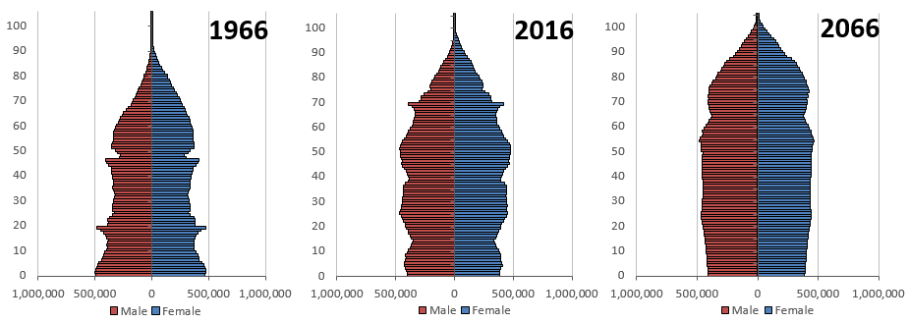

Is it too difficult?
Department of Health paints a gloomy picture and uses v long URLs:
https://www.gov.uk/government/publications/the-future-of-healthcare-our-vision-for-digital-data-and-technology-in-health-and-care/the-future-of-healthcare-our-vision-for-digital-data-and-technology-in-health-and-care
All around us, a new generation of technology is changing our lives, from the everyday use of satnavs and smartphones through to the profound ability of genomics to help us develop personalised medicines for individuals.

Yet the state of online services, basic IT and clinical tools in health and care is far behind where it needs to be. Despite much good practice and some pockets of excellence, for many people – patients, service users, carers and staff – we still need to sort the basics.

Technology systems used daily across hospitals, GP surgeries, care homes, pharmacies and community care facilities don’t talk to each other, fail frequently and do not follow modern cyber security practices. As a result, some people are getting suboptimal care,1,2 staff are frustrated and money could be saved and released for the front line.

Transport: the end of the internal combustion engine?

10 years to ditch fossil fuel car engines, save Paris climate target, warns study
By Sam Morgan | EURACTIV.com https://www.euractiv.com/section/future-of-mobility/news/10-years-to-ditch-fossil-fuel-car-engines-save-paris-climate-target-warns-study/
Europe must stop selling new petrol, diesel and conventional hybrid cars by 2028 in order to stand a better chance of honouring the Paris Agreement’s most ambitious target, according to a new study.Research conducted by the German Aerospace Centre, commissioned by Greenpeace Belgium, says that passenger car engines as we know it need to be completely phased out from new sales before the end of the next decade.
Otherwise, Europe will struggle to “meaningfully contribute” to limiting global warming to 1.5 degrees Celsius, the most ambitious part of the Paris Agreement on climate change’s “well below 2 degrees Celsius” overall aim.

How will artificial intelligence affect the UK economy?
Source PWC
https://www.pwc.co.uk/services/economics-policy/insights/the-impact-of-artificial-intelligence-on-the-uk-economy.html
Highlights
Artificial intelligence (AI) can transform the productivity and GDP potential of the UK landscape. But, we need to invest in the different types of AI technology to make that happen.

Our research shows that the main contributor to the UK's economic gains between 2017 and 2030 will come from consumer product enhancements stimulating consumer demand (8.4%). This is because AI will drive a greater choice of products, with increased personalisation and make those products more affordable over time.

Labour productivity improvements will also drive GDP gains as firms seek to "augment" the productivity of their labour force with AI technologies and to automate some tasks and roles.

Demand for Energy and Future Sources

The growth of energy demand in industry and transport slows while buildings and non-combusted use grow in importance
Source BP https://www.bp.com/en/global/corporate/energy-economics/energy-outlook/demand-by-sector.html
Growth in global energy demand is broad-based across all the main sectors. Differing trends in the way energy is used and consumed in these sectors has an important bearing on the energy transition.
The industrial sector (including the non-combusted use of fuels) currently consumes around half of all global energy and feedstock fuels, with residential and commercial buildings (29%) and transport (20%) accounting for the remainder.
In the evolving transition (ET) scenario, the industrial sector accounts for around half of the increase in energy consumption, although improving energy efficiency causes growth of industrial use outside of the non-combusted sector to slow.
In contrast, the non-combusted use of fuels, particularly as a feedstock in petrochemicals, is projected to be the fastest-growing source of demand.
Energy growth in the buildings sector also grows robustly, driven by an increase in demand for space cooling, lighting and electrical appliances.
The slowing in demand growth is most marked in the transport sector as improvements in vehicle efficiency accelerate.

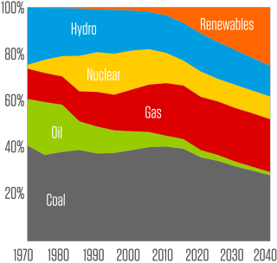 <
The mix of fuels used in power generation is set to shift materially, with renewable energy continuing to gain in importance

A BBC-published list of the ten grand challenges for 2050

Editing genes, ageing populations, rising sea levels… the world is moving faster than ever. What will those trends mean for our society over the next 30 years?
By Bryan Lufkin
http://www.bbc.com/future/story/20170713-what-will-the-challenges-of-2050-be
13 July 2017
Here are just some of the potential big issues of tomorrow:
GENETIC MODIFICATION OF HUMANS
Debates among scientists started roaring last year over a new technology that lets us edit human DNA. It’s called Crispr (pronounced ‘crisper’) and it’s a means of altering people’s DNA to carve diseases like cancer out of the equation.
A MORE AGED POPULATION THAN EVER BEFORE
We won’t just be wrestling with the fact that the world’s population is exploding – but people are living longer than ever, too. Which is great – but all those senior citizens are going to require care. In fact, the number of centenarians will increase more than 50 times – from 500,000 today to over 26 million by 2100. From the UK to Japan to China, societies with large numbers of people over 65 will become more common.
LOST CITIES
You don’t need to look very hard in a place like Miami to see how cities are changing in the 21st Century – rising sea levels are gradually making some of them disappear. Fuelled by climate change, not only are floods becoming more common in the streets, but the changing weather patterns have also influenced building design
THE EVOLUTION OF SOCIAL MEDIA
Social media has complicated the way we communicate for the better part of a decade. And it’s not going anywhere anytime soon, given that most people get their news from it now. That’s before we even get into the mess of online harassment, as well.
NEW GEOPOLITICAL TENSIONS
The past year has seen a complete upset of our geopolitics’ fragile balance. That could make the global stability of the next couple of decades a complete question mark.
North Korean missile launches. Thousands of refugees crossing borders to flee turmoil. Hackers meddling in other nations’ elections. Rising nationalist sentiment worldwide. Headlines in 2016 (and so far, 2017) have been dominated by never-ending political drama that’s been fuelling a ‘geopolitical minefield’ and an ‘unprecedented geopolitical shift’ –
SAFE CAR TRAVEL
Despite all the rapid urbanisation and talk of bullet trains and fantastical technology like the Hyperloop coming to the fore, the car isn’t going anywhere – and in fact, in the next couple decades, there will be even more of them on the road.
Driverless car technology is swiftly rolling out, with major tech companies and automakers aggressively seeking to debut human-free vehicles in coming years. But in addition, the sheer number of cars – self-driving or not – is going to skyrocket, studies show.
DWINDLING RESOURCES
The new tech and devices that characterise the 21st Century all require rare earth metals to make – an average smartphone has over 60 “ingredients”. That’s putting a strain on the planet’s natural resources: in China, where 90% of the world’s rare earth metals are found, it’s estimated that its mines will run out in the next two decades – and good substitutes for those materials are hard to come by.
SETTLING OTHER WORLDS
How will space tourism companies make sure their activities are safe? How will we find ways to send humans to Mars or another planet to live there, as Stephen Hawking has urged us to figure out?
BOOSTED BRAINPOWER
It’s already common to use drugs to boost brainpower (whether it’s coffee, or something stronger, like modafinil), and most of the developed world now relies on their smartphones as an ‘externalised’ memory – but let’s extrapolate that out a few decades. Imagine targeted pharmaceuticals that make us think faster than currently possible, and technological implants that help us concentrate beyond normal human ability for hours or days, for example – these advances are already well underway in laboratories around the world.
AI’S DOMINANCE IN OUR LIVES
Futurist Ray Kurzweil has made a host of predictions – some inspirational, others downright alarming. One of them is the sci-fi-sounding notion that suggests artificial intelligence will one day become more powerful than human intelligence and improve itself at an exponential rate, otherwise known as ‘the singularity’.

Case studies of past disruptive change

Case study 1: Photographic Film and Music

Industry shift: what changed, and what was driving that change
Photography and music are two areas where digital technology has changed products, materials and lifestyles. Photography witnessed evolution for the first 100 years followed by revolution.
1883 Invention of roll film followed by photo film in 1885
1908 Safety film
1975 The digital camera. Invention credited to Steven Sasson of Eastman Kodak.
1976 to 1996 Market Peak for Eastman Kodak with 90% market share for film, revenues of $16bn and 145,300 employees.
Materials
Photographic film is a strip or sheet of transparent plastic film base coated on one side with a gelatin emulsion containing microscopically small light-sensitive silver halide crystals
Digital photography uses memory based on silicon and other materials for electronic circuits.
New market opportunities
Digital cameras as stand-alone and integrated devices such as mobile phones, dashcams and doorbells. Software. Cloud services. Social media. Instagram. Disruption of the media as individuals could be photo-journalists and social media became intertwined with news publishing.
Market size
The market for digital cameras is actually predicted to decline by half, from almost $20bn, over the next five years but that underplays the significance of cameras in mobile phones, online services etc.

The music industry also saw a shift at around the same time.
1877 Phonograph
1948 Introduction of Vinyl LP
1962 Introduction of Compact Cassette
1981 CD
1988 CD sales exceed LPs (150m to 72m in the US)
1991-2001 Napster music file sharing by download
1994 First generation of one-chip MP3 players
2000 Commercial MP3 players.
2001 iTunes and IPod introduced
2008 Spotify – subscription based music access
2018 CD sales fall by 90% over 10 years, Downloads fall by almost 60% in five years from 2012 peak
Disruption
Multiple, from Vinyl to CD to Download to subscription without ownership.
Material and manufacturing
Continuous improvement in quality with vinyl and then CD. Change to electronic memory, like photography and ultimately sharing model in the cloud.
New markets
Based on connectivity the storage medium gave way to the cloud. Digital distribution and creation removed the need to manufacture a product with associated start-up costs opening the opportunity to challenge record companies and publishers through direct release by musicians.
Conclusion
The photography and music industries are examples of sectors disrupted by social or behavioural trends, enabled by technology and with disruption far beyond the simple change in manufactured product.

Case study 2: Logistics
Industry shift: what changed, and what was driving that change
Demand side shifts have driven the transformation of the logistics industry accompanied by supply-side changes, particularly connectivity and cost pressures for fuel and labour.

Home delivery is nothing new. The Electric Vehicle Association claimed, in 1967, that the UK had more electric vehicles than any other nation and nearly all of them were milk floats delivering recyclable bottles of milk to consumers. But, the dairy set the round and the timing and the sophistication of ordering was limited to a note for “two extra pints” on the doorstep.

Milestones in delivery services
1635 The Royal Mail
1840 The Penny Black
1991 Internet opened to commercial use
1977 Just in time manufacturing recognised in the West (Nissan UK plant 1984)
1992 Lean Manufacturing, Toyota UK plant
1994 Founding of Amazon
2000 GPRS data service over second and then third generation mobile networks

What was the innovation?
There have been multiple innovations in logistics that have helped the industry transform and address the growing challenges it was facing – these include the use of tracking technology as well as route planning using data and analytics to optimise deliveries and minimise costs.
Tracking of vehicles has enabled both better logistics planning, but also enabled customers, consumers and businesses, to be better informed of the time of their delivery. In addition, analysis of that data has helped optimise routes.
One widely quoted innovation is from UPS, who over 10 years ago stopped their drivers taking left turns (which is equivalent to our right turns in the UK). The logic was that by waiting in traffic to make the turn, this burned more fuel, and the turn across oncoming traffic also had the potential for more collisions. As a result, UPS says it has saved over 10 million gallons of fuel since then, and reduced emissions equivalent to taking over 5,000 cars off the road for a year.
New markets
The deployment of tracking technology enabled other types of sensors to be incorporated too – such as temperature and relative humidity. This became a significant opportunity in addressing the needs of the food and pharmaceutical industry, especially for perishable foods and temperature critical drugs. These two sectors have strict safety and regulatory requirements.

Tracking technology along with internet of things (IoT) connectivity and analytics have enabled this market to be addressed effectively, but it does require investment in technology.

Conclusion
The digital transformation that the logistics industry has undergone was necessary for the businesses to survive. However, with tracking and analytics, the logistics companies have both addressed their need to stay relevant and have also been able to address areas like cold supply chain logistics for the food and pharmaceutical sectors.

The impact on the business-to-business realm has been dramatic for manufacturers and more widely. In business-to-consumer the change in employment patterns and disruption of traditional retail has been dramatic.

Studio 10, Tiger House, Burton Street, London, WC1H 9BY
info@ncub.co.uk +44 (0) 2073837667 @NCUBtweets www.ncub.co.uk

Jobs and growth: the importance of engineering skills to the UK economy, RAEng, 2012
Four steps to define digital skills, Readie/Nesta, 2018
‘The relation between 21st-century skills and digital skills: A systematic literature review’. Van Laar et al. (2017)
Greener skills and jobs, OECD Green Growth Studies, OECD/Cedefop, 2013
Engineering UK – The state of engineering 2018, Engineering UK, 2018
Delivering STEM skills for the economy, NAO, 2018
Roehampton Annual Computing Education Report, University of Roehampton, 2018
Shut down or restart? The way forward for computing in UK schools, Royal Society, 2012
See source 5
See source 5
See source 6
‘A longitudinal evaluation of the impact of STEM enrichment and enhancement activities in improving educational outcomes’. Banerjee (2016).
‘Career guidance and the changing world of work’. T. Hooley (in press)
Cedefop Skills Panorama
Delivering STEM skills for the economy, HoC Committee of Public Accounts, 2018
Skills Shortages in the UK Economy, The Edge Foundation, 2018
Skills Forecast: key EU trends to 2030, Cedefop, 2018
Helping the UK thrive, CBI/Pearson Education and Skills Survey 2017, CBI, 2017
In perfect harmony. Improving skills delivery in England, CBI, 2018
Working Futures 2014-2024, UK Commission for Employment & Skills, 2016
See source 5
See source 1
The Future of Skills: Employment in 2030, Nesta & Pearson, 2017
Does the EU need more STEM graduates? Teknologisk Institut, Denmark, 2015
Employer Skills Survey 2015: UK results, UKCES, 2016
What type of future workforce will the UK need? Foresight/GOS, 2013
New Skills Agenda for Europe: Working together to strengthen human capital, employability and competitiveness, EC, 2016
Digital skills and inclusion - giving everyone access to the digital skills they need, DCMS, 2017
Digital skills for the UK economy, BIS & DCMS, 2016
Shadbolt Review of Computer Science degree accreditation and graduate employability, BIS, 2016
Building a Britain fit for the future, HM Government, 2017
Sector insights: skills and performance challenges in the digital and creative sector, UKCES, 2015
Lifelong digital skills development, current picture and future challenges, Foresight/GOS, 2016
Strategic Skills Assessment for the Creative Industries, Creative Skillset, 2010
Skills Framework for ICT, SkillsFuture. Singapore
Data Science and Analytics Skills Shortage: Equipping the APEC Workforce with the Competencies Demanded by Employers, Asia-Pacific Economic Cooperation, 2017
On AI and Robotics - Developing Policy for the Fourth Industrial Revolution, University of Manchester, 2018
Growing the Artificial Intelligence Industry in the UK, BEIS & DCMS, 2017
Machine learning: the power and promise of computers that learn by example, Royal Society, 2017
The impact of artificial intelligence on work, Royal Society & British Academy, 2018
Big Data Analytics. An assessment of demand for labour and skills, 2012-2017, e-skills, 2013
Big Data Analytics. Assessment of demand for labour and skills 2013–20, Tech Partnership, 2014
See source 32
Skills for a green economy: a report on the evidence, HM Government, 2011
See source 4
Green skills, National Bureau for Economic Research, 2015
Energy Production and Utilities: Sector Skills Assessment 2012, UKCES, 2012
Nuclear workforce assessment 2017, Cogent/Nuclear Skills Strategy Group, 2017
See source 29

